

Adapt IT Consulting and Training

**INTEGRATOR 4.1 – TRAINING MANUAL**

**Finance System**

**Cashbook**

Copyright

©All rights reserved

No part of this document may be reproduced or transmitted in any form or by any means, without express written permission from Adapt IT or an authorised representative of Adapt IT. This includes, but not limited to, electronic, electrostatic, magnetic tape or mechanical copying and recording, or use of any information storage and retrieval system.

First edition: February 2018

Disclaimer

Adapt IT makes no representations or warranties with respect to the contents hereof. Although due care and precaution has been taken in the preparation of this manual, Adapt IT assumes no responsibility for errors and omissions or any damages resulting from the use of the information contained in this publication.

**Contents**

**Course Overview** 1

**Course duration** 1

**Pre-requisite knowledge and skills** 1

**Course content** 1

**Learning outcomes** 1

Module Structure 2

**System Access** 3

**Logging on to Integrator** 3

**Forgot Password** 4

**Landing Page** 6

**Navigation** 6

**Exiting a form** 6

**1** **System Requirements** 7

1.1 Introduction 8

1.2 Links to Other Subsystems 8

1.3 Maintain Cashbooks {FCSC-5} 9

1.4 Maintain Account Categories {FCSC-7} 11

1.5 Maintain Transaction Type Definitions {FCSO-7} 12

1.6 Maintain User Restrictions {FCSP-2} 16

1.7 Control Issue of Receipts/Payments {FCTM-1} 17

1.8 Maintain Cashier ID and Password {FCTM-2} 18

1.9 Cashier Sign-on {FCTO-1} 20

**2** **Cashbook MPM** 22

2.1 Introduction 23

2.2 Cashier login 23

2.3 Maintain Statement Journals {FCBO-1} 24

2.4 Manage Manual Bank Statements {FCBO-2} 28

2.5 Bank Statement Reconciliation {FCBO-4} 31

2.6 Manage Cheque Matching 32

2.7 Cashbook Transfers {FCBO-5} 32

2.8 Maintain Electronic Bank Statement {FCBO-21} 33

2.8.1 Match Bank Statement 36

2.8.2 Edit Bank Statement 36

2.8.3 Payments 37

2.8.4 Deposits 38

2.8.5 EFT 38

2.9 Process Incoming Bank Files {FACMR1-2} 38

2.10 Maintain Electronic Statement- Standalone {FCBO-28} 39

2.11 Query Unreconciled Cheques {FCBO-6} 40

**3** **Query Menus (not in MPM)** 42

3.1 Introduction 43

3.2 Query Budget GLA {FCBO-9} 43

3.3 Query Statement Journals {FCBO-10} 44

**4** **Reports** 46

4.1 Introduction 47

4.2 Receipt / Payment Transactions per Type {FCTOR1-1} 47

4.3 Bank Statement {FCBOR1-1} 48

4.4 Bank Reconciliation {FCBOR1-2} 48

4.5 Receipt Payments Not Deposited {FCBOR1-5} 49

4.6 Deposit Validation Report {FCBOR1-7} 50

4.7 Bank Reconciliation as at a Specific Date {FCBOR1-10} 51

**Acronyms, Glossary & Terminology** 52

**Acronyms** 52

**Glossary** 53

**Terminology** 54

**Help us enhance the course** 56

**Need help?** 57

**Course Overview**

Welcome to the ITS Integrator course for the Cashbook subsystem. This course is designed to equip you with the skills and knowledge you need to be a cashbook administrator. In fact, it is essential for anybody who will be responsible for the cashbook at an institution.

**Course duration**

1 day

**Pre-requisite knowledge and skills**

Before you can register for this course, you must have attended the interface training so that you have the minimum knowledge of system navigation.

**Course content**

The course structure is divided into modules and covers the following:

|  |  |
| --- | --- |
| **Subsystem** | **Modules** |
| Cashbook | * System requirements * Cashbook MPM * Query menus * Reports |

**Learning outcomes**

On completion of this course, the trainee should be able to:

* Set-up system pre-requisites.
* Utilise the cashbook MPM.
* Query cashbook information.
* Generate cashbook reports.

## Module Structure

Each module contains the following parts:

**Specific outcomes**

The specific outcomes are very important because they state what is expected of you.

**Introduction**

Each module starts with a statement of the content and learning outcomes for that module in order to introduce you to the subject matter of the module. Suggested time allocation is also indicated. Bear in mind that the time allocation is only a guide and some people will take longer than others to complete the same task. The timeframe can also be longer if you choose to look up content from other resources.

**Content**

Module content consists of information moving from system pre-requisites to operational and menu management issues. The content is subdivided into topics, tasks, procedures and other information arranged in a logical sequence and broken down into small, connected and understandable units. This content can be supplemented by support materials such as PowerPoint presentations, worksheets, hand-outs, etc.

**Acronyms, Glossary and Terminology**

As far as possible, the workbook uses clear and non-technical language. However, it is inevitable that you will be introduced to new terminology or be faced with the use of acronyms to describe or explain the contents of this manual. All terminology and/or acronyms used will be explained in the content, but you will also find separate structured tables at the end of this manual.

**System Access**

**Logging on to Integrator**

To access Integrator, you need the use of Internet Explorer. Using your browser, use the URL relevant to your institution or link from the institutions’ local Intranet. You will be prompted for your user name and password. Username and passwords are set up in User Access Definitions {USERS-5} and maintained by the institution. A user can have multiple logins with the same user ID. It is dependent on institution rules and policies. Additionally, unsuccessful logging attempts might be limited to a specific number depending on the institution’s policy.

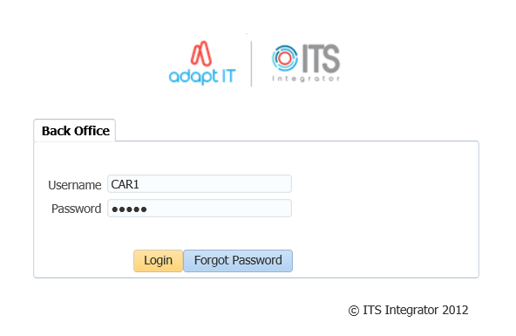

1. Type in your username and password
2. Click on the Login button

**Forgot Password**

If you are having difficulty logging in to Back office or you forgot your password, you can reset your password.

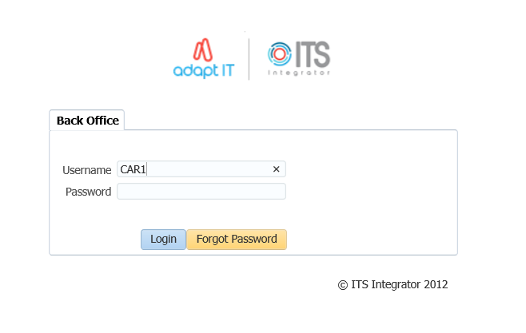

1. Enter your Username
2. Click on the “Forgot Password” button

To be able to reset ITS/OID password, the users email address must be set up on {PBOP-14}/ {GOPS-3} and Primary Indicator for the email must be set to “Y”. If security questions are not set up on {USERS-17}, the user will get login control message to set up password questions and Answers.

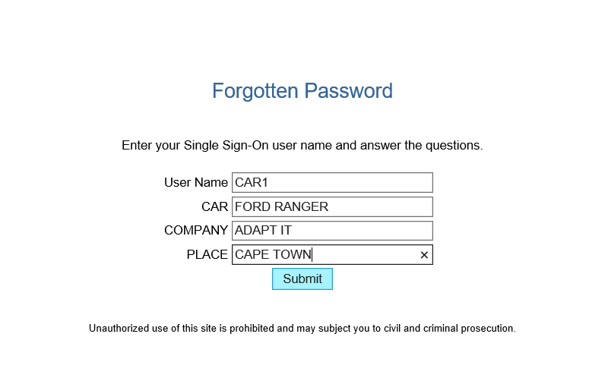

1. Answer the questions as set on {USERS-17}
2. click on “Submit button”

The notification pop up message to be illustrated

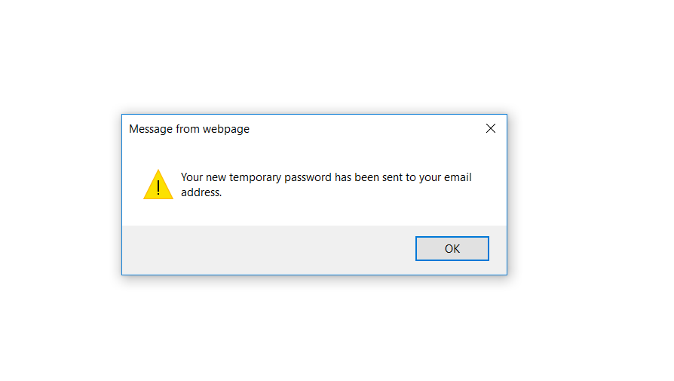

Logging in to ITS Integrator again with the given password on the email



On the main page after logging onto integrator, on the More Tab, the Forgot Password Q and A can be found here and this will direct the user to {USERS-17}

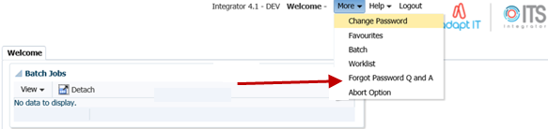

**Landing Page**

After logging into the Integrator Back Office System, the Integrator Entry Screen will display. The Integrator Entry Screen is the gateway to the full Integrator Back Office System and consists of four sections: Header, Main Menu Bar, Work Area, Welcome and Footer.

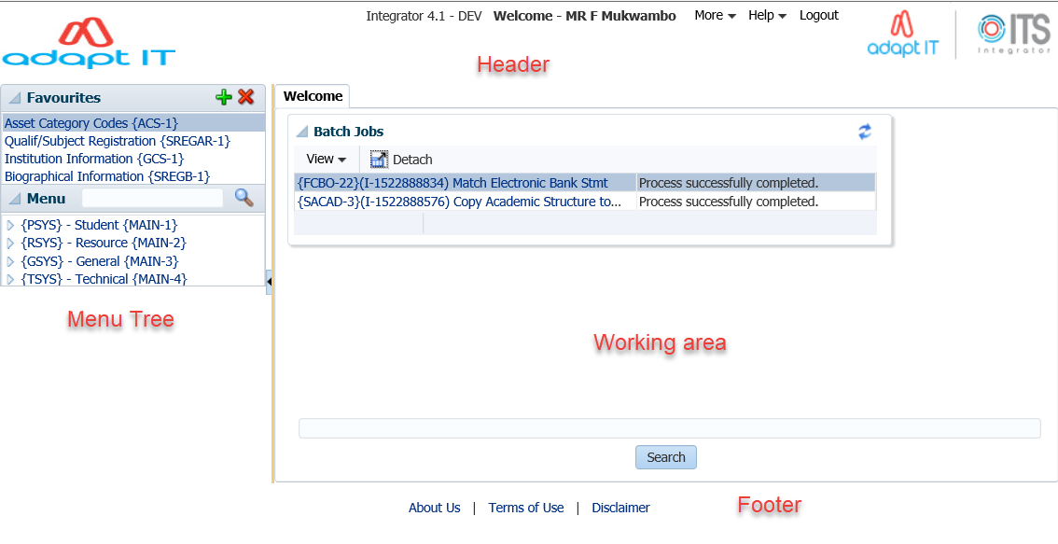

**Navigation**

Integrator 4.1 requires that you use the mouse to move from one field to another. In previous versions, the user could navigate between fields using the Tab and Enter keys. However, the new ADF technology operates in a browser and shortcut keys do not always give the intended output.

**Exiting a form**

Use the Green door cid:image002.png@01D3D71D.D09EFC60 (old forms) or the black cross cid:image003.png@01D3D71E.8FFFE7E0  (new ADF forms) to exit forms programs in Integrator 4.1.

The Abort Option button is only for emergencies in the event of a menu option hanging.

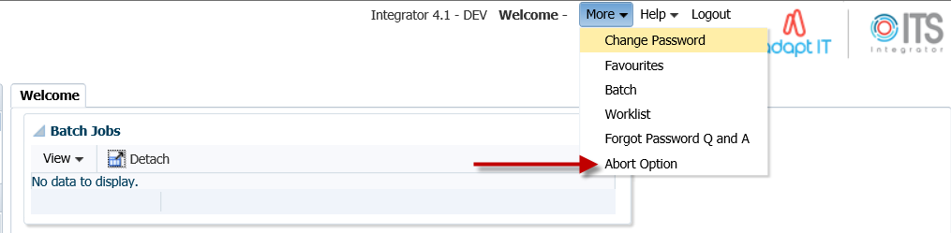

**MODULE**

**1**

# **System Requirements**

Specific outcomes

On completion of this module, you will be able to:

* Link the cashbook to other subsystems
* Maintain cashbooks
* Maintain account categories
* Set subsystem statuses
* Maintain cashier ID and password
* Log on and off the cashbook

## Introduction

The system provides the facility to administrate cashbooks, perform bank reconciliations as well as financial reporting. This facility makes provision for the creation of multiple cashbooks, updating of cashbook journals, and the entering of bank statements followed by a reconciliation process. The cashbook consists of 2 sets of tables, namely cheque tables and journal tables. The cheque tables contain the detail of all the individual cheques generated, irrespective of the subsystem of origin. The journal table contains 3 types of transactions:

* Transactions with the total value of an ACB tape or bank draft payment every time that type of payment is generated. They can originate from any subsystem.
* Whenever a deposit list is generated, a transaction reflecting that deposit is created in this table. Deposits are driven by event “CB” and a transaction type should be linked to this event. Separate deposit lists can be produced for credit card, drafts and all other types of payments received.
* Transactions that originate from the bank statement, e.g. bank charges, interest paid or received, etc. are also stored in this table.

A specific cashbook must be associated with all transactions involving a bank account. This is done in two ways:

* For all cheque and receipt transactions a transaction type must be used. The specific bank account is identified by the cashbook code field on the specific transaction type. This implies that there must be different transaction types for the same type of transaction but for different cashbooks.
* The cashier must identify a specific cashbook before journal transactions can be entered. The specific cashbook is not identified on the transaction type. This implies that the same transaction type can be used for the same type of transaction for different cashbooks, e.g. bank charges or interest.

## Links to Other Subsystems

The ITS systems are designed to eliminate the entering of duplicate information in different subsystems. The subsystems are thus integrated and interdependent. Consequently, the implications for the cashbook subsystem are:

* All payments received and cheques made out by this system should be posted to specific General Ledger Allocations, which must be predefined in the Financial Code Structure subsystem.
* User-defined transaction types drive the Financial system. For the cashbook subsystem, receipt transaction types and payment transaction types must be defined in option {FCSO-7} in the Financial Code Structure subsystem.
* Different Cashbooks are maintained in option {FCSC-5}, and these are then linked to the different subsystems in which cheques are generated
* Validation is done against student, debtors, creditors and personnel numbers.

The debit/credit indicator on the transaction type for CB has the same meaning as in the Counter Subsystem, that is:

* “D” means it is a debit in the “Other” subsystem involved and a credit in the cashbook as identified by cashbook code and the relevant debit GLA must be supplied. The credit GLA will default from the cashbook definition.
* “C” means it is a credit in the “Other” subsystem involved and a debit in the relevant cashbook and a credit GLA must be supplied. The debit GLA will default from the cashbook definition.

Given that the GL-Allocations are already set-up in the Financial Code Structure subsystem, the user should also set-up the cashbooks, account categories, subsystem status and login credentials in the Cashbook subsystem.

## Maintain Cashbooks {FCSC-5}

The user will first have to create a cashbook and if necessary the ACB users. The cashbook, ACB users and subsystems must then be linked. In option {FCSC-5}, the user can define a cashbook for each of the institutions bank accounts or search for existing cashbooks.

**See Example below {FCSC-5}**

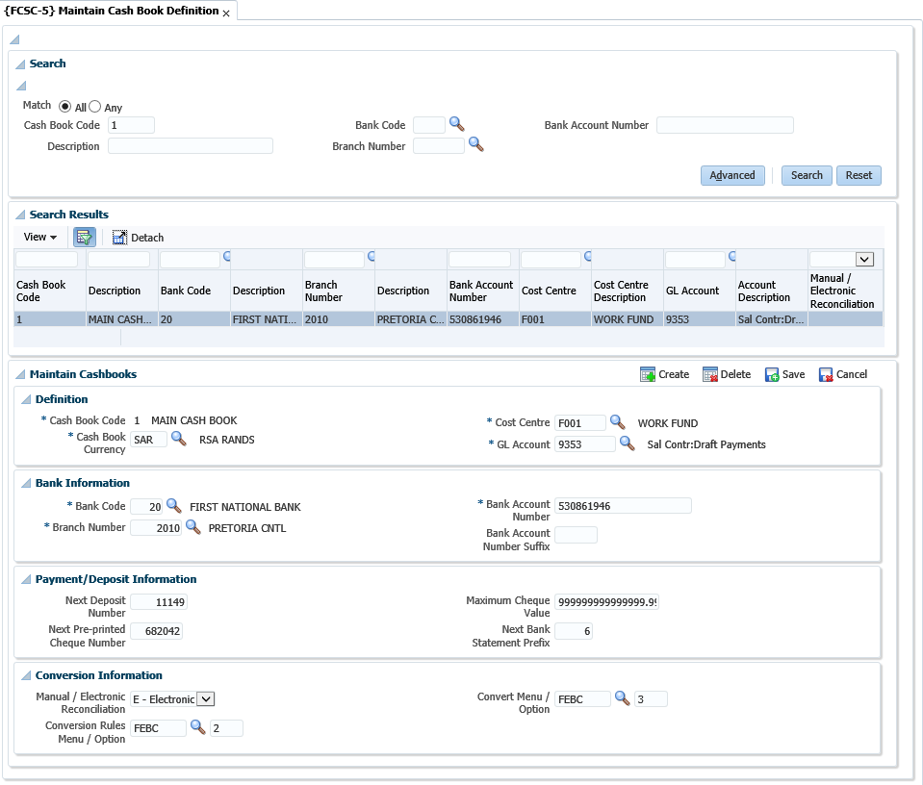

**Search panel box**

The search panel allows the user to search using a cashbook code, description, bank code, branch number or bank account number and the records returned are displayed in a table. Records in the table are not updateable and the user must use the form layout (panel box 2) to enter or edit cashbook definition details.

**Definition panel box**

**Cashbook Code**: Supply a unique code for this Cashbook.

**Cashbook Description**: Supply a suitable description for the code.

**Cashbook Currency**: Supply the currency for this Cashbook. Currencies are defined in option {FCSO-21}

**Cost Centre**: Supply the cost centre for this cashbook.

**GL Account**: Supply the Account which together with the Cost Centre represents the general ledger allocation (GLA) for this Cashbook. The system will use this GLA whenever transactions are created for this Cashbook. Cost Centre is defined in option {FCSO-1}, Account {FCSO-3} and GLA {FCSO-6}

**Bank Information panel box**

**Bank Code**: Supply the code of the Bank relevant to this Cashbook defined in menu option {FCSM-4}.

**Branch Number**: Supply the number of the Bank branch relevant to this Cashbook defined in option {FCSM-4}.

**Bank Account Number**: Supply the number of the Bank account number relevant to this Cashbook. This is the number as allocated by your bank. This account number usually appears at the foot of a cheque. The format may vary between banks, the most common format being 334945: 0610.511.645" 26.

**Payment and Deposit Information panel box**

**Next Deposit Number**: Whenever a Bank Deposit is generated, the system will automatically allocate a deposit number to the document. The number will be retrieved from this field and the next number will be allocated.

**Next Pre-printed Cheque Number**: Whenever a cheque is generated, the system will automatically allocate a number to the cheque. The number will be retrieved from the table in option {FCTM-1}, resulting in only one range of internally generated numbers for cheques. It is however, true that different series of cheque numbers (refer pre-printed number on the cheque) will be used for the different subsystems or cashbooks. The number maintained in this field, is the next pre-printed number. When cheques are printed in options {FCTO-22}, {FPMOPD-27} and {FPRN-6} or {FPRN-21}, the system will request the next pre-printed number. The system will then increment the number for the number of cheques generated and this field will be updated.

**Maximum Cheque Value**: This is the maximum amount for which the ITS system may generate a cheque. This value will be used in the Finance subsystem as well as the Payroll subsystem.

Where the ITS system generates a cheque with an amount greater than the maximum cheque amount a fatal error will occur.

**Next Bank Statement Prefix**: Some banks restart there bank statement number at 1 when a max statement number was reached. To make provision for more than one bank statement range, same range, add a numeric prefix in this field before starting the second, third… etc. ranges

**Conversion Information panel box**

**Manual / Electronic Reconciliation**: Indicate whether the cashbook is being reconciled manually or electronically. The conversion codes for electronic reconciliation are defined in {FCSC-23}. This menu option is maintained by Adapt IT and users cannot execute any updates.

**See Example below {FCSC-23}**

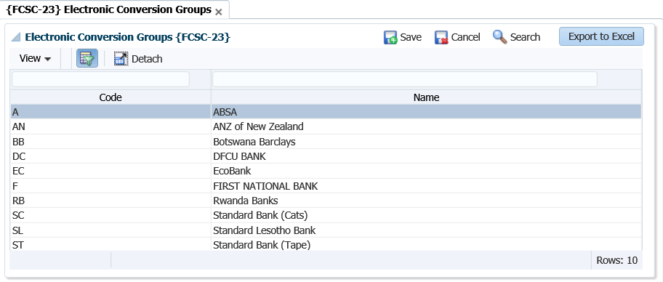

**Conversion Rules Menu / Option**: The menus and the option for the setup of the bank’s conversion rules.

**Convert Menu / Options**: The menu and the option to convert the statement for the cashbook.

**Note:** The cashbooks, ACB users and subsystems must then be linked. The cashbook can be affected by transactions from the Counter (CT), Procurement Management (PM), Payroll (PR), Cashbook (CB) and Long -Term Loans (LL) subsystems. The cashbook must therefore, be linked to each of these in {FCSC-26}.

**See Example below {FCSC-26}**

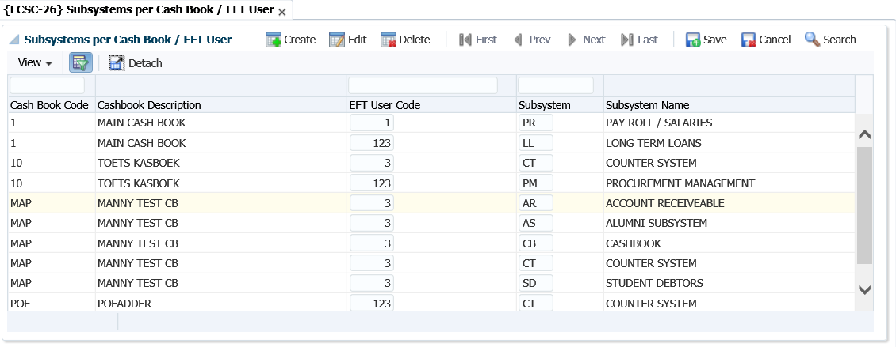

## Maintain Account Categories {FCSC-7}

The valid account categories that can be used in the Cashbook subsystem must be declared. Under this option, the user can define account categories and restrict the access of individual subsystems per account category. A standard set of account categories required for STATS reporting is supplied with the system. The numbering of the standard set of account categories allows the users to create new categories (user defined) with the understanding that newly created account categories will be accumulated into the preceding standard one.

**Note**: The user should not only understand that the table may be updated by the user and that categories can thus be deleted, but also that the supplied account categories are pre-defined into some programmes and therefore that deletions of the supplied account categories could cause problems in the STATS reporting. Deletion of a category is only allowed if there are no accounts linked to that specific category.

**See Example below {FCSC-7}**

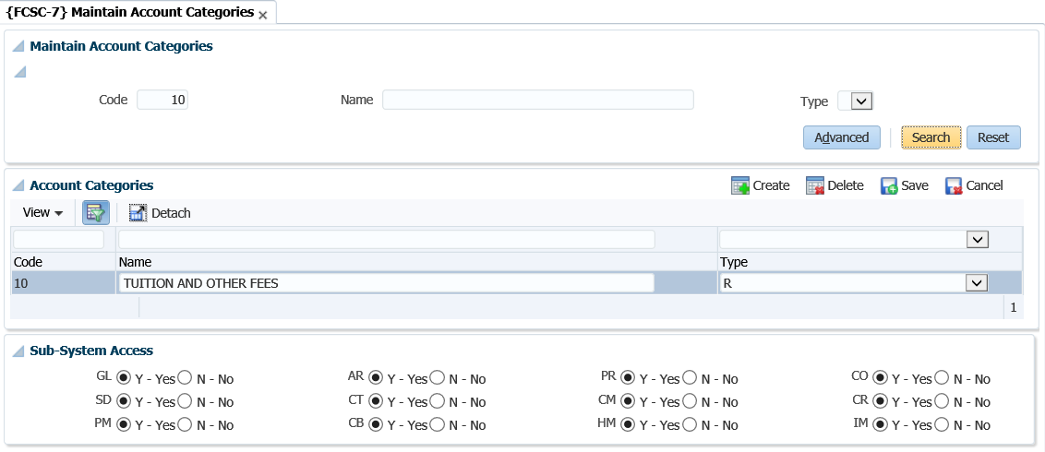

**Code**: Supply a unique number for this category.

**Name**: Supply a suitable description for this category.

**Type:** Choose the relevant type for this category. Categories are divided into 4 types, namely:

* Revenue
* Expense
* Assets
* Liability

**Sub-system Access**: Columns are displayed with the codes of the different subsystems as headings, and the user can indicate with a radio button whether this category is accessible to the specific subsystem.

## Maintain Transaction Type Definitions {FCSO-7}

A transaction type can be described as a “pre-defined journal type”. All financial transactions must be recorded against a transaction type. The basic characteristics and advantages of a transaction type are:

* It is specific for each subsystem.
* A transaction type is either a debit or a credit transaction for the subsystem (this is not applicable to GL transaction types)
* Where you have TT defined for specific type of transactions, mistakes in respect of GL allocations can be minimized.
* Decisions on accounting principles are taken away from juniors.
* The process of automatic transactions is simplified.
* Makes reporting easier where you are looking for type of “journals”.

Each cashbook needs a debit, credit and a VAT transaction type which will be used in menu options {FCTO-3} and {FCTO-6}. Very important is to remember that the indicator “Income or expense cashbook” must be set to ‘Income’, otherwise the user will not be able to use these in {FCTO-3}.

Credit transaction type {FCSO-7}.

**See Example below {FCSO-7}**

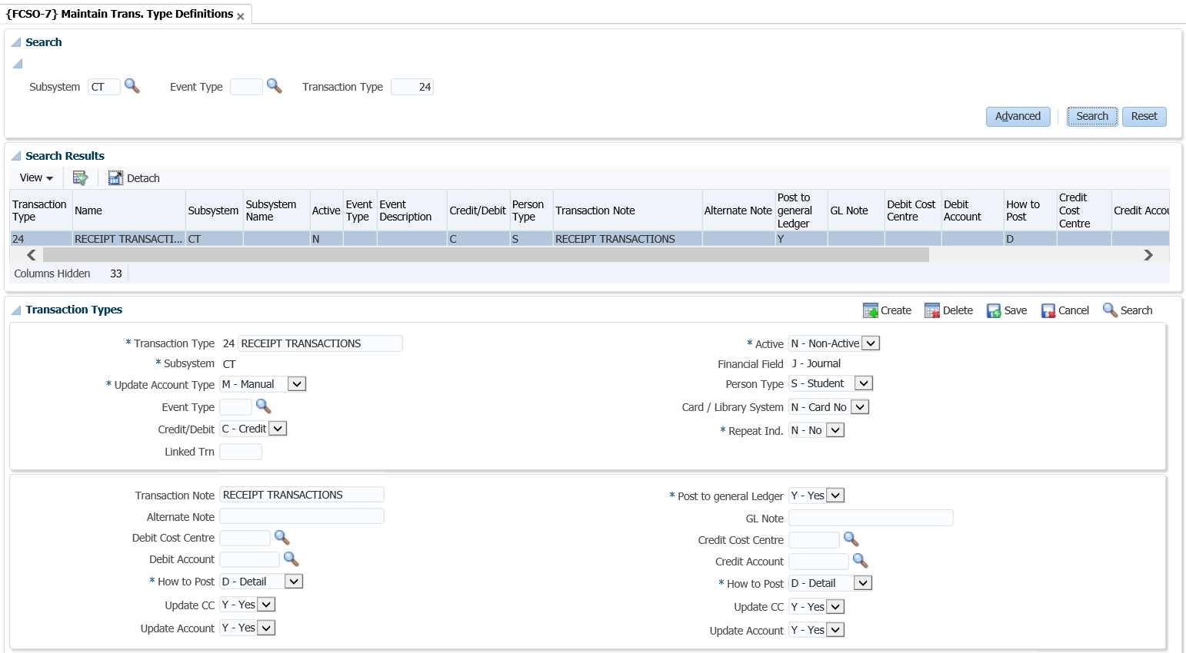

**Field in this option:**

**Type**: Enter a unique code for your TT. It is recommended that you use number ranges for each subsystem. That way you know that all the CT transaction types are within the range 1000 to 1999 etc.

**Name**: Give a description of the transaction type. Remember that this should be done so that all users would know which transactions will be recorded against this code.

**Active Indicator**: Is the TT active or not? You will make use of this where you may have used a TT for specific purposes, but no longer want the users to use this. So, then you query the code and make it non- active. This means no user will be able to record transactions against this TT.

**Subsystem**: Enter the subsystem for which the transaction type is valid.

**Default value:** This field will be completed if the transaction type is usually for a specific value. This amount will default when used, but the users can still override the amount.

**Financial field**: This field will indicate what ‘type’ of transaction this TT will record. You have the following options:

* (S)-balance: this is where the system is calculating a brought forward balance.
* (B)udget: this will be for budget transactions as they are reported in different columns in the GL reports.
* (J)ournal: these are the ‘normal’ financial transactions and most of the transaction types will be linked to this field.
* (C)ommitment: these are for the PM system. An example would be where requisitions/order are created. The system will create a transaction in the commitment column of the GL reports.

**Cashbook code**: This field is mandatory if the subsystem is CT and will indicate the cashbook code this TT is relevant to. Where you have more than one cashbook, but you have the same type of transaction for multiple cashbooks you would create “duplicate” transaction types but indicate in the description for which CB code it will be used.

**Income / Expense**: This indicator is only relevant to the CT and CB systems. This is to differentiate between transactions affecting (I)ncome and (E)xpense on the cashbook.

**Update type**: This field can either be manual or automatic. Most of the TT definitions will be linked to manual. The automatic will be if the TT is linked to an event (see next field).

**Event Number**: This field will list all the predefined events. These events are defined by Adapt IT: Pretoria and you will ONLY link this to the relevant TT code. An event number will be “triggered” by specific programs to use TT automatic without a user selecting them. For the SD fees structure the system have the link between the TT and the events in the option {FSAM-29}.

**Repeat Indicator**: The user may specify repeating transactions in the Procurement Management (PM), Accounts Receivable (AR) and General Ledger (GL) Subsystems. Whenever the applicable screens are used, the system will control that a transaction type with a (Y)es in this field is used. The number of repetitions and the intervals will be specified, and the program will generate transactions accordingly.

**Credit / debit**: What must happen to the debtor/creditor account? For example, if it is the SD system, should the student be debited or credited?

**Person type:** This can also be referred to as the debtor/creditor type. This field is applicable where the subsystem is CT or CB. The system wants to know, if this transaction takes place what other ‘subsystem’ must be affected. Remember that where the person type is student, it will also reflect on the students’ account in the SD system.

The ‘Other’ person type is used where you have sundry transactions that are not for a debtor or creditor account.

**Linked transaction**: This field will be completed if this TT that you are busy defining can have VAT. The VAT portion will be recorded against the TT entered in this field.

**Card/Library system?** If you are using the meals (card) or library system, then TT can be defined to receipt money in those specific ‘accounts. The field will be used where the subsystem is CT. This field must be set to yes if you want to use it for those types of receipts.

**Transaction note**: This field is the note field that will default when the TT is used when a transaction is processed. Enter a note that will best describe the transaction to the debtor/creditor as this will display on their statements.

**Alternate note**: This field is the same as the transaction note field. This description will be used if you have indicated on the debtor/creditor biographical detail their preferred language is not ‘English’ but ‘Alternate’.

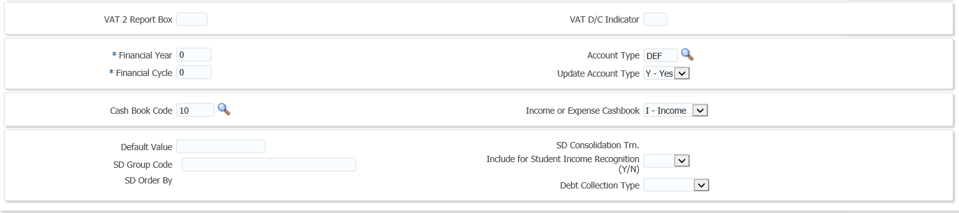

**VAT 201 box report**: This field is applicable if you are registered for VAT and do VAT reporting through the system. The box numbers with their information can be obtained from the receiver of revenue.

**VAT D/C indicator**: This field is applicable if you are registered for VAT. It will be used to indicate if it is a debit or credit to the VAT transactions.

The following fields are all display fields and the detail are defined in the SD system:

* SD group code
* SD order by
* SD consolidation transaction
* Include for consumption report Y/N?

**Post to general ledger**: You will usually set this field to yes. This indicates if the transaction should be posted to the GL. This field is not applicable to the GL system as the transaction is already ‘in’ the GL system.

**Debit GLA**: Enter the GLA to be debited. This field will be completed if there is a specific GLA that must be used OR where the GLA can’t be blank when automatic (TT linked to an event) transactions take place.

**Update CC**: Is the user allowed to change/update the CC? This field can only be set to NO if the “Update Type” field is set to (M)anual.

**Update account**: Is the user allowed to change/update the account? This field can only be set to NO if the “Update Type” field is set to (M)anual

**How to Post**: Do you want to post the transactions in detail or summary to the GL? If set to summary, the system will accumulate all transactions (since the last posting) for the specific account which has not yet been posted, and post one transaction.

It is recommended that you make the debit GLA indicator ‘summary’ for all debit transactions and the credit GLA indicator summary for all credit transactions. This will mean your GL reports are not that cluttered. Should you wish to see how the summary posting is made up you can request a report from the menu {FGLP}.

**Financial year**: This field is only relevant for TT linked to the GL system. This is where you wish to process transactions for a financial year that is different to the financial year of the system as indicated in {FCSM-2}. For all the other subsystems this field will have a value of zero, as the transactions will use the financial year as indicated in {FCSM-2} for the relevant subsystem.

**Financial cycle**: This is only valid for the GL system, for the rest of the subsystems set this value to "00".  If a transaction type is meant to be valid only during a specific cycle, the user may enter a value equal to or greater than the present financial cycle, or in all other cases "00" (zero). If zero, the system will default to the cycle of the subsystem. Transaction Types linked to sub-system GL are subject to the setting of rule GH, of the system operational definitions, on menu option {[FCSM-1](http://wlint4.adaptit.co.za:7221/itshelp/faces/helppages/config.OHW+Servlet+1/vtAnchor.Block_2/topics/navSetId.itshelp/itshelp/documents/fcsm-1.html#Block_2)}, TAB - System Operation Definitions.

* Rule [GH](http://wlint4.adaptit.co.za:7221/itshelp/faces/helppages/config.OHW+Servlet+1/vtAnchor.GH/topics/navSetId.itshelp/itshelp/documents/fcsm-1.html#GH) provides the facility to prevent the update of the financial year and cycle for Ledger journals. Whenever the user supplies a transaction type on any of the GL journal screens, may the user update the financial year and cycle, (Y)es or (N)o? This rule must also be read in conjunction with rules GC and [GY](http://wlint4.adaptit.co.za:7221/itshelp/faces/helppages/config.OHW+Servlet+1/vtAnchor.GY/topics/navSetId.itshelp/itshelp/documents/fcsm-1.html#GY).
* Rule [GC](http://wlint4.adaptit.co.za:7221/itshelp/faces/helppages/config.OHW+Servlet+1/vtAnchor.GC/topics/navSetId.itshelp/itshelp/documents/fcsm-1.html#GC) provides the facility to allow Ledger journals to be processed in previous cycles and rule GY provides the facility to allow Ledger journals to be processed in previous years.

**Account Type**: Supply the default Account Type to be used. This is not a mandatory field. Account Types may only be defined for sub-systems AR, CM, PM and SD. Account Type definitions are defined on menu option {[FCSC-21](http://wlint4.adaptit.co.za:7700/itshelp/faces/helppages/config.OHW+Servlet+1/topics/navSetId.itshelp/itshelp/documents/fcsc-21.html)}:

* Where the [subsystem](http://wlint4.adaptit.co.za:7221/itshelp/faces/helppages/config.OHW+Servlet+1/vtAnchor.Subsystem/topics/navSetId.itshelp/itshelp/documents/fcso-7.html#Subsystem), is PM, the <LIST> function will only contain active Accounts Types defined for PM.
* Where the [subsystem](http://wlint4.adaptit.co.za:7221/itshelp/faces/helppages/config.OHW+Servlet+1/vtAnchor.Subsystem/topics/navSetId.itshelp/itshelp/documents/fcso-7.html#Subsystem), is AR, the <LIST> function will only contain active Accounts Types defined for AR.
* Where the [subsystem](http://wlint4.adaptit.co.za:7221/itshelp/faces/helppages/config.OHW+Servlet+1/vtAnchor.Subsystem/topics/navSetId.itshelp/itshelp/documents/fcso-7.html#Subsystem), is CM, the <LIST> function will only contain active Accounts Types defined for CM.
* Where the [subsystem](http://wlint4.adaptit.co.za:7221/itshelp/faces/helppages/config.OHW+Servlet+1/vtAnchor.Subsystem/topics/navSetId.itshelp/itshelp/documents/fcso-7.html#Subsystem), is SD and [Card System](http://wlint4.adaptit.co.za:7221/itshelp/faces/helppages/config.OHW+Servlet+1/vtAnchor.Card/topics/navSetId.itshelp/itshelp/documents/fcso-7.html#Card), is (Y)es, the <LIST> function will only contain active Account Types for the CM.
* Where the [subsystem](http://wlint4.adaptit.co.za:7221/itshelp/faces/helppages/config.OHW+Servlet+1/vtAnchor.Subsystem/topics/navSetId.itshelp/itshelp/documents/fcso-7.html#Subsystem), is SD and [Card System](http://wlint4.adaptit.co.za:7221/itshelp/faces/helppages/config.OHW+Servlet+1/vtAnchor.Card/topics/navSetId.itshelp/itshelp/documents/fcso-7.html#Card), is (N)o, the <LIST> function will only contain active Account Types for the SD.
* Where the [subsystem](http://wlint4.adaptit.co.za:7221/itshelp/faces/helppages/config.OHW+Servlet+1/vtAnchor.Subsystem/topics/navSetId.itshelp/itshelp/documents/fcso-7.html#Subsystem), is CT or CB, the <LIST> function is dependent on the values of [Debtor/Creditor type](http://wlint4.adaptit.co.za:7221/itshelp/faces/helppages/config.OHW+Servlet+1/vtAnchor.Person_Type/topics/navSetId.itshelp/itshelp/documents/fcso-7.html#Person_Type), and, if applicable, [Card System](http://wlint4.adaptit.co.za:7221/itshelp/faces/helppages/config.OHW+Servlet+1/vtAnchor.Card/topics/navSetId.itshelp/itshelp/documents/fcso-7.html#Card).

**Update Account Type**: Can the User update the Account Type (Y)es/(N)o. When this Transaction Type is used, may the user update the Account Type?

## Maintain User Restrictions {FCSP-2}

Before a cashier can start entering transactions, user restrictions can be set up to restrict the cashiers to only have access to specific cashbooks.

**See Example below {FCSP-2}**

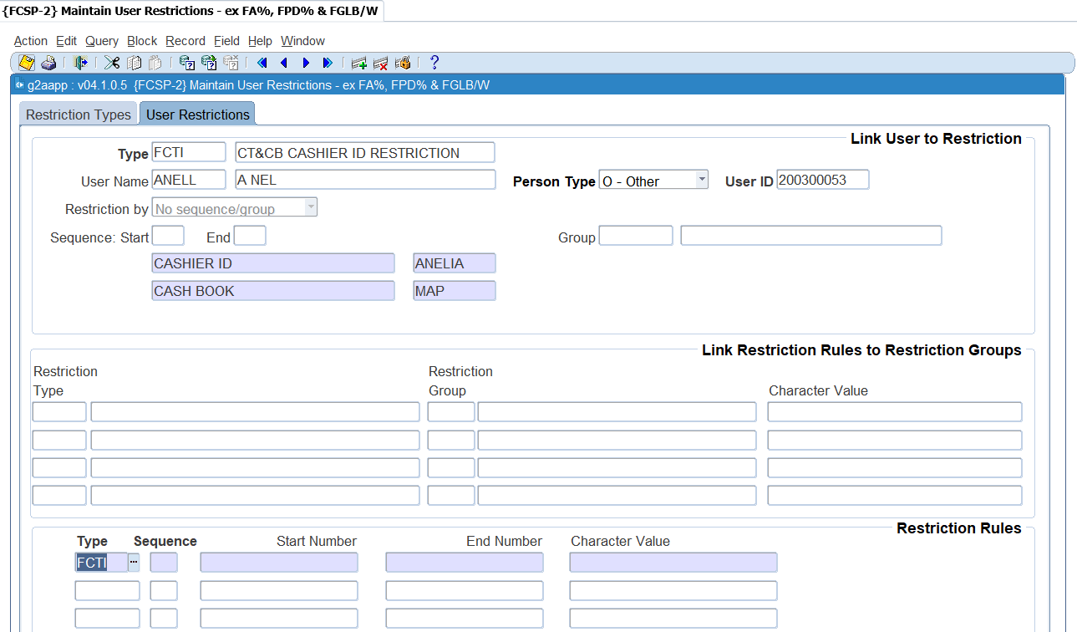

**Importance of user restrictions**

* This would, for instance, allow each faculty/school to see and update only its part of the financial data.
* This facility, combined with the normal access control with "updating" and "read only" privileges {USERS-2}, provides for powerful and flexible access and update control. This option should be under the control of one or two senior financial users.
* Restrictions form part of the Routing Set-up {GROU-1} to {GROU-4}. When the user is restricted to a specific cost centre, limit or account category, the routing as set-up in {GROU-1} will pick-up who to notify for doing the approval on a specific document, etc.

## Control Issue of Receipts/Payments {FCTM-1}

In this option, the user (normally the finance officer) may query the status of the subsystem, activate and de-activate it, and control transaction, receipt, cheque and payment numbers. For example, in the morning the system will normally be activated for receipts only.  At a specific time of day this status could be changed to payments, or receipts and payments, thus allowing the user to produce daily payments.  If a function (receipts or payments) is “inactive”, updating of the applicable screen will be impossible.

**See Example below {FCTM-1}**

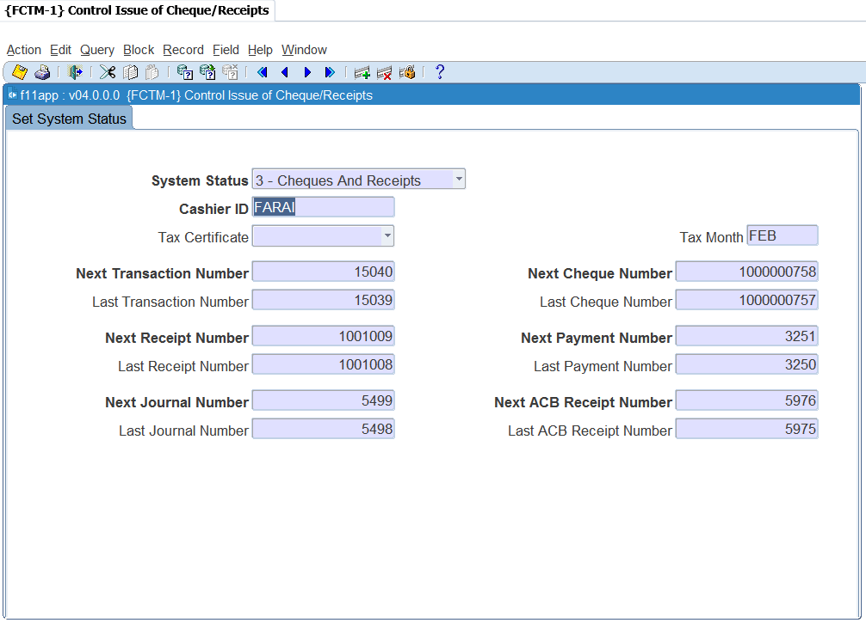

**System Status**: Select from the list of values for the appropriate activation and the list contains the following:

* Inactive
* Only receipts
* Only cheques
* Cheques and receipts

**Cashier**: The name of the Control Officer/Cashier, with powers between 80 and 99, who is resetting the status and updating receipt, cheque, payment or transaction numbers.

The next two fields refer to Receipt Transactions:

**Tax Certificate**: The default for the Tax Certificate Indicator on {FTXO-1} when the debtor type of the debtor code is of the category (C)ontact. Value that can be inserted is Yes, No or Null from the list of values.

**Tax Month**: The Tax Certificate year end month e.g. JAN, FEB, MAR, etc.

**Last/Next Transaction Number**: The last and next transaction numbers used and to be used.

**Last/Next Receipt Number**: The last and next receipt numbers used and to be used.

**Last/Next Cheque Number**: The number of the last cheque used and the next number to be issued.

**Last/Next Payment Number**: The last payment number used and the next number to be used.

**Last/Next ACB Number**: The last ACB receipt number used and the next ACB number to be used.

**Last/Next Journal Number**: The number of the last Journal used and the next number to be issued.

**Note**: The user may change these numbers but may only increase them.

## Maintain Cashier ID and Password {FCTM-2}

The financial system requires a high level of security, which should be controlled by financial staff. This system provides a facility whereby a senior finance officer can create and maintain cashiers’ ID’s and passwords. In effect, the user will appoint cashiers, grant powers, assign a printer to the cashier and control the passwords.

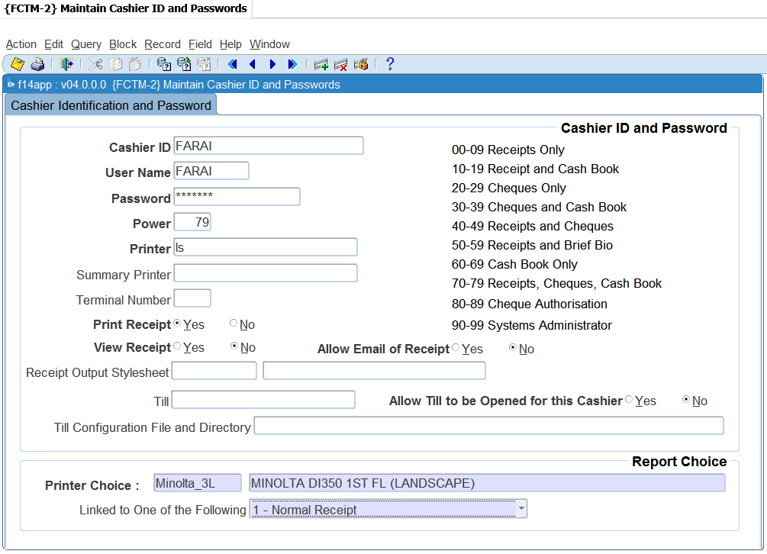

**Cashier ID and Password**

**Cashier ID**: Enter the name to uniquely identify the cashier in the system. This ID will accompany all transactions generated by this cashier.

**User Name**: Enter the user name of the same person for whom the cashier ID is being created. All programs where a cashier ID is required will validate that the person logged onto the system and the cashier ID being used correlates to the cashier ID and user linked in this option. A user will then only be able to use the cashier ID linked to his or her user code.

**Password:** Enter the secret password of the cashier. This field is encrypted, which means that the text cannot be seen on the screen. The finance officer will create a password that is easy to remember, notify the cashier of the password and request the cashier to change it immediately using option {FCTO-1}, Cashier Sign-On. This changed password cannot be seen on any report or screen, and only the cashier will know what it is.

**Power**: Powers will normally range between 00 and 79 which represent normal cashiers, powers between 90 and 99 being reserved for systems managers. The system manager can thus grant activating powers to other senior people. The codes and meaning of the powers are explained on screen.

**Printer:** The UNIX or other O/S printer name of the destination printer for receipts issued by this cashier. If no printer is specified, the system will queue the receipt internally in spooler files. In block 2 the user can specify the type of stationery which will be in a specific printer.

**Summary Printer**: This field is used to enter a name of a printer that will allow you to print the summary of the receipt information on a document e.g. the back of a cheque. In order to do this, the printer of the cashier should be linked to report choice 7 - Normal and Summary Receipt. A summary printer must also be defined as part of the cashier ID definition.

**Terminal Number**: When this screen is queried, the system will display the number of the terminal that was used when the cashier signed on.

**Print Receipt**: The system can be set to allow or to suppress the printing of receipts per cashier. This is only a default value that will be used for the cashier when receipts are processed on {FCTO-3}. It can be changed by the cashier for individual receipts.

**View Receipt**: The system can be set to allow the cashier to view a receipt before printing or emailing it. This is only a default value that will be used for the cashier when receipts are processed on {FCTO-3}. It can be changed by the cashier for individual receipts. The printer that is linked to the cashier, is linked to the choice of receipt 9

**Allow Email of Receipt**: The system can be set to allow or to suppress the emailing of receipts per cashier. If set to no, the cashier will not be able to mail receipts at all. If set to yes, the cashier can email the receipts when it is captured on {FCTO-3}. It can be changed to NO by the cashier for individual receipt.

**Receipt Output Style Sheet**: the style sheet that will be used to view and email receipts. For printer choice 9, this will be the same layout as the printed receipt. For all other printer choices, the layout differs from the printed receipt.

**Note:** If you have pre-printed stationery, or you are using line printers and you want to use the ‘old’ format of the receipt printing, then this field must be left null. If you want to make use of the new format of printing, you must insert the style sheet code f1101pdf and link the printer to receipt choice 9.

**Till**: this field will only be used when the equipment used allows the till drawer to be opened electronically. This is typically where the computer is linked to a drawer that is like a cash register. Enter the UNIX or other O/S name of the till to be opened for this cashier. The till name must be defined as a printer in {GPRT-1}

**Allow Till to be opened by this Cashier**: If equipment is used that allows the till drawer to be opened electronically, the functionality can be restricted to specific cashiers only. A cashier can only open a till drawer electronically if this field is set to 'Y'

**Till Configuration File and Directory**: this field contains the configuration file and location that will determine the communication parameters passed to activate the port linked to the physical printer.

**Report Choice**



**Printer Choice**: the printer to be used is queried and selected from the list of pre-defined printers. After selection of the printer, the type of stationery can be selected. The following is available from the list of values:

1. Normal Receipt
2. Receipt and ID Combination
3. Multiple Receipts per Page
4. L/S Normal Receipt
5. L/S Receipt and ID Combination
6. L/S Multiple Receipts per Page
7. Normal and Summary Receipt
8. L/S/ Normal and Summary Receipt
9. Style Sheet Format

After selecting the stationery type, <SAVE> the information in order to link the printer to the stationery type.

**Note:** That when selecting option (2), if an unregistered student pays, a receipt will be printed in the format of option (3) above with ***STUDENT NOT REGISTERED*** on the receipt. Option (3) can be selected if the user wishes to print receipts on official letterheads and print multiple receipts per page.

In the event of local software stationery, select the appropriate local software applicable to the printer selected above.

## Cashier Sign-on {FCTO-1}

The Finance Officer creates a password in option [{FCTM-2](http://wlint4.adaptit.co.za:7700/itshelp/faces/helppages/config.OHW+Servlet+1/locale.en/topics/navSetId.itshelp/itshelp/documents/fctm-2.html)}, notify the cashier of the password and request him/her to change it immediately through option {FCTO-1}.  This password is encrypted and can thus not be seen on any report or screen, i.e. only the cashier will know his/her own password. Once an ID and password have been granted to a specific cashier, the cashier becomes operational. Before a cashier can start entering transactions, s/he will be prompted to “sign-on” as a user in the menu option they will be working in.



**Note:** When allocating the cashier's ID and password, the controlling officer will also assign the printer to which this cashier's printing will be directed. The user has a choice regarding the format of receipt to be printed. Receipt formats are selected in {FCTM-2}.

If the cashier wants to change his/her password, the following two fields will be used. The system displays text, “To Change Password". The password cannot be “updated” on the “sign-on” screen, and cashiers must first sign-off and then sign-on again to change the password.

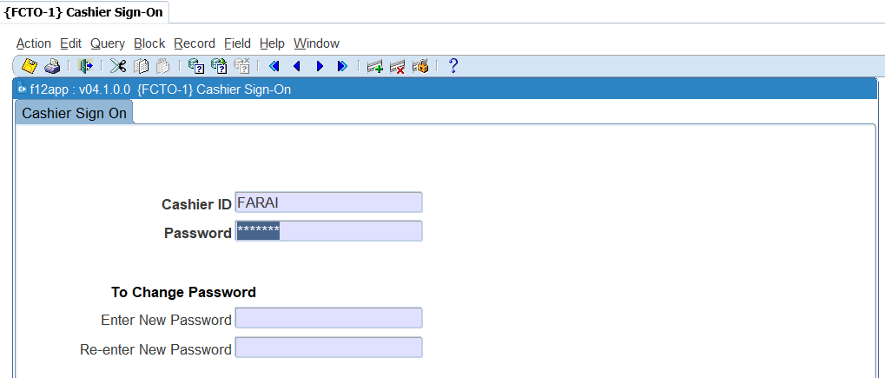

This screen cannot be queried.

**Cashier ID:** Enter the name of the cashier.

**Password:** Cashier must enter the secret password.

**Enter New Password:** Enter new password

**Re-enter New Password:** Re-Enter the new password and <SAVE>.

**MODULE**

**2**

# **Cashbook MPM**

Specific outcomes

On completion of this module, you will be able to:

* Create cashbook journals.
* Duplicate cashbook journals.
* Reverse cashbook journals.
* Manage manual bank statements.
* Perform bank statement reconciliations.
* Execute cashbook transfers.
* Maintain electronic bank statements.

## Introduction

This option is the Multi Process Management (MPM) for cash book and is consists of the following panel boxes: Search, Bank Statements for, Transactions for Statement and Tasks. The aim of an MPM is to empower the user to work with an entity (in this case the cash book) using only one menu option. This will provide a 360-degree view of the cash book, the transactions linked to the cash book, details of the transactions, as well as allow the user to create new transactions or edit existing ones. A cash book code must be entered in the 'Search' Panel Box in order to use this option and will default to all the tasks that the user accesses.

**Cash Book MPM {FCBO-11}**

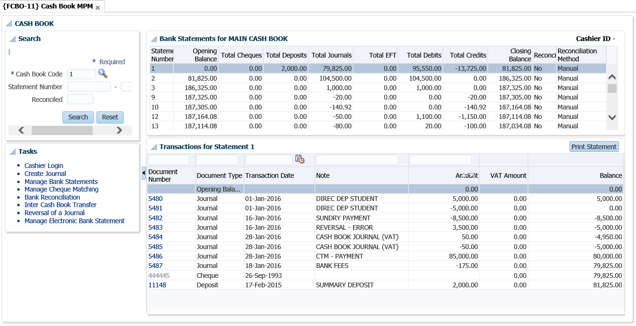

## Cashier login

Users with access to cash book options can query cash book transactions but to process a transaction, the user must be a cashier that is logged on i.e. cashier must have a valid ID and password. The program will validate that the user logged onto the system and the cashier ID entered refer to the same person. It does this by checking if the cashier ID is linked to the user in {[FCTM-2](http://wlint4.adaptit.co.za:7700/itshelp/faces/helppages/config.OHW+Servlet+1/topics/navSetId.itshelp/itshelp/documents/fctm-2.html)}.

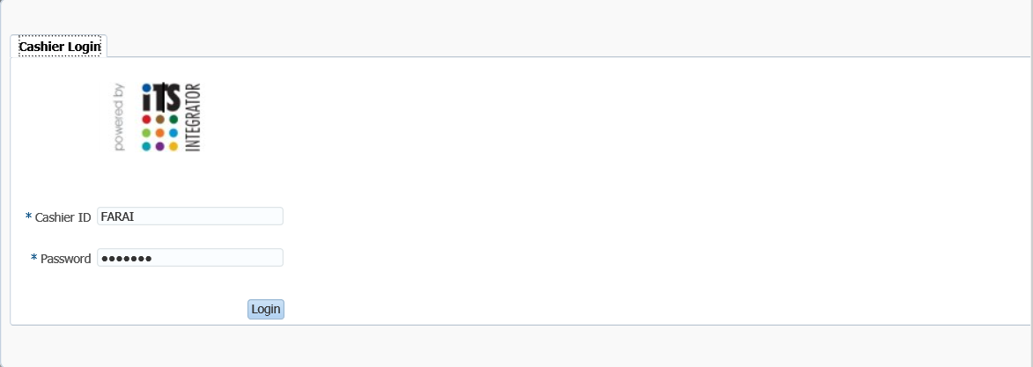

## Maintain Statement Journals {FCBO-1}

The purpose of this menu option is to enable processing of bank statement transactions and subsequently post them to the general ledger. When this option is selected, the system requests the ID and password of the cashier as defined in {FCTM-2} in block 1, and the cashbook code the user intends to work on in block 2. Additionally, system operational definition '[C7](http://hawkapp.its.co.za:7772/itshelp/help/state/content/navId.2/navSetId.itshelp/vtTopicFile.itshelp%7Cdocuments%7CC7CB/)' for subsystem 'CB' (Receive money for student with action 'S') exists in {[FCSM-1](http://hawkapp.its.co.za:7772/itshelp/help/state/content/navId.2/navSetId.itshelp/vtTopicFile.itshelp%7Cdocuments%7Cfcsm-1%7Ehtml/)} to determine if the user may accept money for a student with a status with action 'S' linked. If (N)o, the user will not be able to receive money for a student linked to a status with action 'S'. If (Y)es, the user will only receive a warning that the student is linked to a status code with action 'S'.

**Create Journal**

The Create button allows the user to create a manual cashbook journal.

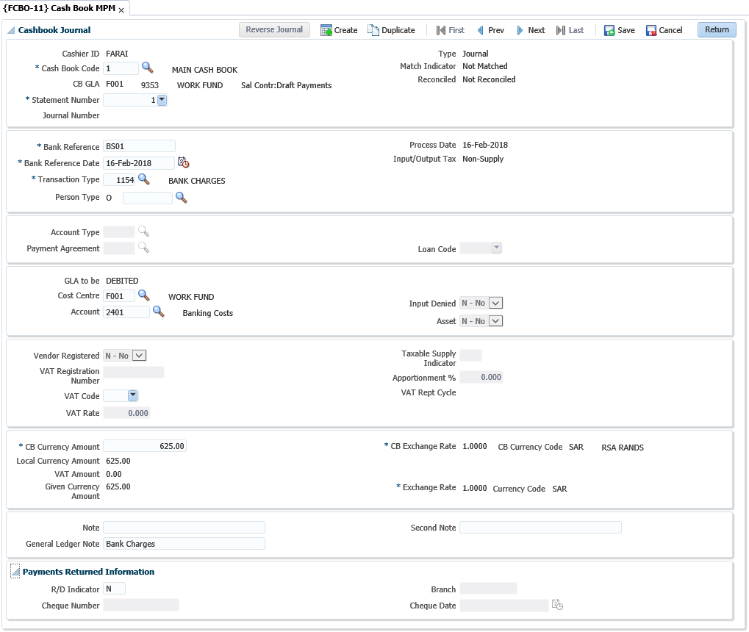

**Note:** All transactions entered here are treated as normal journals and will be posted to the general ledger if indicated as such, irrespective of whether they are matched or not. Transactions will also be generated in the other relevant subsystem.

**Cash Journal panel box**

**Cashier ID**: The cashier ID will display as created for the user on {FCTM-2}.

**Cashbook**: Enter the cashbook code. A list of values is available displaying all the valid cashbooks with their code and description.

**CB GLA**: Displays the cashbook GLA as defined in {[FCSC-5](http://wlint4.adaptit.co.za:7700/itshelp/faces/helppages/config.OHW+Servlet+1/topics/navSetId.itshelp/itshelp/documents/fcsc-5.html)} "Maintain Cashbook Definition".

**Statement Number**: Enter the statement number. A list of values is available displaying all the statement numbers for the cashbook.

**Journal Number**: This is a unique transaction number which is allocated programmatically to every transaction

**Bank Reference**: The reference number of the transaction as it appears on the bank statement.

**Bank Reference Date**: The reference date of the transactions as it appears on the bank statement.

**Process Date**: The process date will default to system date and is not updateable.

**Transaction Type**: Enter the transaction type defined on {FCSO-7}.

**Person Type**: Depending on the transaction type definition, one of the following values will be displayed: (S)tudent, (D)ebtor, (C)reditor, (A)lumnus, (O)ther or (P)ersonnel. The adjacent person number field is mandatory if the person type of the transaction is (S)tudent, (D)ebtor, (C)reditor, (P)ersonnel and (A)lumni. For person type (O)ther, this field is not mandatory, but a number can be used if the person was created on the system.

**Account Type**: the account type will default from the transaction type, but will be updateable by the user if it is defined on the transaction type definition.

**Note:** The account type field is mandatory if the person type of the transaction is (S)tudent, (D)ebtor or (C)reditor. A list of valid account types for that person type will be available. For (P)ersonnel and (O)ther, this field is also mandatory if the card indicator on the transaction type definition is (Y)es.

**Payment Agreement**: Whenever a transaction is processed for person type (S)tudent, the user will have to enter a payment agreement for the transaction. If the transaction is processed against the default account type, this field will be null.

**Loan Code**: The staff loan code or student loan code can be entered here.

**GLA to be**: Indicates if the GLA will credited or debited.

**Cost Centre**: Displays the cost centre for the transaction. The cost centre is not updateable if the person type is Student, Creditor or Debtor or where an account type is used.

**Account**: The account to be debited or credited. The account is not updateable if the person type above is Student, Creditor or Debtor or where an account type is used.

**Input Denied**: The indicator defaults from the account definition. If the journal relates to a taxable supply on the input side and the indicator is (Y)es, GST / VAT will not be processed when the journal is saved. The journals will be marked as input denied.

**Asset:** If the journal relates to the sale or purchase of an asset the indicator should be set to (Y)es. The indicator will be used to identify capital items for GST / VAT reporting purposes. The value defaults according to the asset categories as defined on the SOD codes AV and AW.



**Vendor Registered**: Vendor registered only applies to SA clients registered for VAT, where the journal relates to input. In order to claim the input VAT on the journal the field vendor registered must be set to (Y)es. If the field is "Y" the cashier will be required to enter the vendors VAT registration number. This forces the cashier to enter a VAT registration number where input tax will be claimed.

**VAT Registration Number**: If the field vendor registered is set to (Y)es, the cashier must enter a VAT registration number. The program will validate that the number is a valid VAT number applying the SARS modules check.

**Vat Code**: For money received, the VAT Code defaults from the credit GLA cost centre definition. For payments, it defaults from the Cost Centre of the debit GLA.

**Vat Rate**: The VAT percentage linked to the VAT code will default but can be updated by the user. It is the user's responsibility to ensure the VAT rate is correct on commit of the transaction.

**Taxable Supply Indicator**: Taxable supply indicator is used to classify a transaction in terms of its treatment for VAT / GST purposes. The taxable supply indicator is linked to the GST / VAT code and by selecting a GST / VAT code, the taxable supply indicator is set. The following indicators are available:

* Taxable Supplies
* Standard Rated Supplies
* Zero Rated Supplies
* Exempt Supplies
* Deemed Supplies
* Change in Use
* Bad Debts
* Non-Taxable Supplies

**VAT Apportionment**: Where a journal is directly attributed to the making of a taxable supply there is no apportionment and the apportionment is 100% rate = 1. However, if the journal relates mixed supplies, apportionment applies and only a portion of the input tax can be claimed. The portion that can be claimed is referred to as an apportionment. Apportionment rates to be applied should be obtained from the local tax authority.

**Note:** Apportionment is only applicable if the journal relates to input. The apportionment rate defaults from the rate definition but it is the cashier’s responsibility to ensure the GSWT / VAT apportionment is correct on commit of the transaction. The rate is entered in decimal notation.

**VAT Report Cycle**: Displays the VAT Report Cycle. When a transaction is reported in a VAT report, the transaction is flagged with the report year and cycle it was reported in.

**CB Currency Amount**: The transaction value in cashbook currency i.e. the amount as it appears on the bank statement.

**Local Currency Amount**: The CB currency amount converted in the currency of the institution.

**Vat Amount**: The VAT amount, if VAT is applicable will display.

**Given Currency Amount**: The value of the transaction, in each currency. Given currency value is the value of the transaction in the currency of the Debtor / Creditor after converting the Cashbook amount received to local currency and the local currency value to the debtor / creditor currency.

**CB Rate**: The cashbook currency exchange rate.

**CB Currency Code**: The currency code of the cashbook. The cashbook currency defaults from the cashbook definition and cannot be updated.

**Given Currency Rate**: The exchange rate of the currency the Debtor / Creditor is defined in.

**Currency Code**: The currency code of the currency the person, Debtor / Creditor, is defined in. The code defaults from the person’s biographical definition and cannot be updated.

**Note**: A note for the subsystem transaction may be entered. If the debtor / creditor is a (S)tudent, the note will default from the transaction type note, but may be updated.

**General Ledger Note**: The debtor number and name will default to this field but may be updated by the user. This note will be entered in the General Ledger.

**Second Note**: A second note field can be entered for the transaction. This field can be updated after the transaction is saved. If the field is entered, it will print on the transaction list. If null, the GL Note will print on the transactions list {FCBOR1-6}.

**Payments Returned Information panel box**

**Set R/D Indicator**: If an R/D cheque is processed, this indicator may be set to (Y)es.

**Cheque Number**: If a cheque was returned from the bank, the cheque number of the returned cheque can be entered here.

**Branch:** The branch code of the returned cheque can be entered here.

**Cheque Date**: The date of the returned cheque can be entered.

**Reverse Journal**

The Reverse Journal button allows the cashier to reverse a cashbook journal. A pop-up window will appear, and the user will enter the details of the original journal to be reversed.

**See Example below {FCBO-1}**

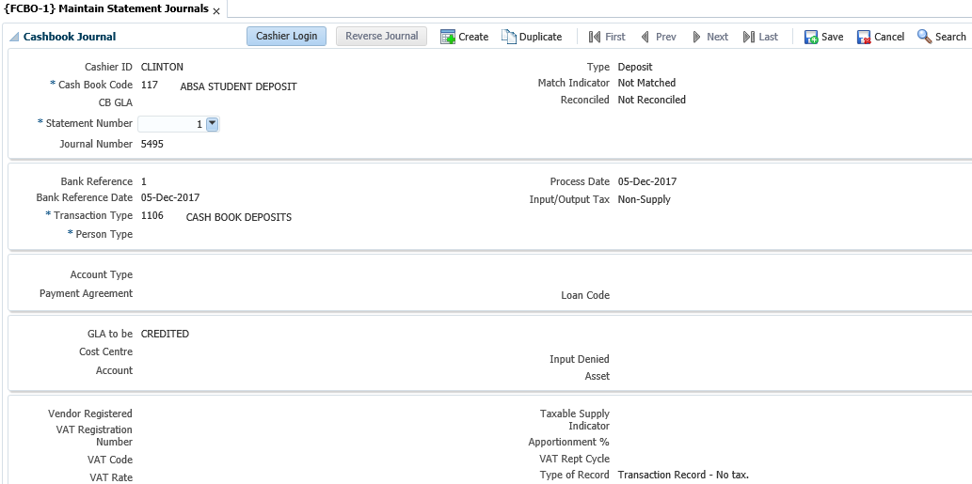

**Duplicate Journal**

Allows the cashier to duplicate a cashbook journal and the journal fields will be pre-filled. (See page 25 for a detailed explanation of the journal fields.)

## Manage Manual Bank Statements {FCBO-2}

This option is used to match transactions on a bank statement (Cheques, Deposits and EFTs) to what exists on the system. If corresponding transactions are found, the normal match indicator is set, and the statement number is stored with the transactions. Items that are not found are stored on a scratch pad table for force-matching. If no transaction appears, it means that the user will have to enter the transactions to link to the statement. Program has been amended by changing the LOV on cash book to show all cash books, not only Manual.

The following screen shows a scenario in which all transactions have been matched.

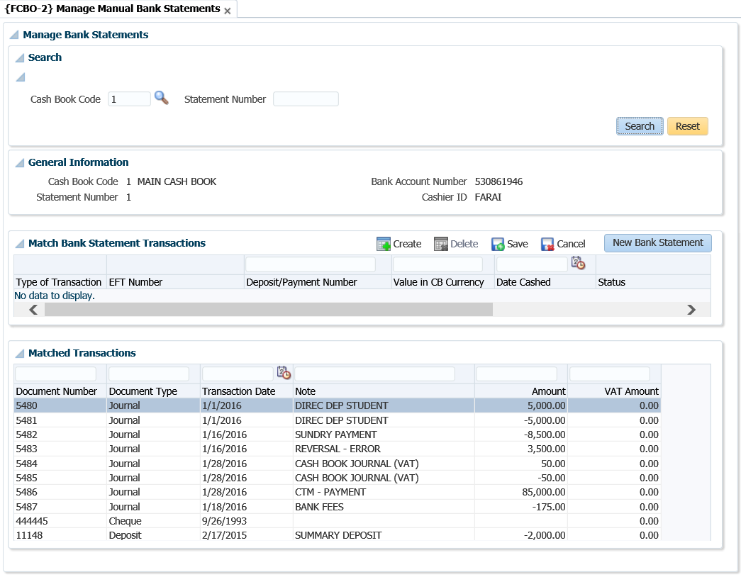

The following screen shows a scenario where some transactions still need to be matched.

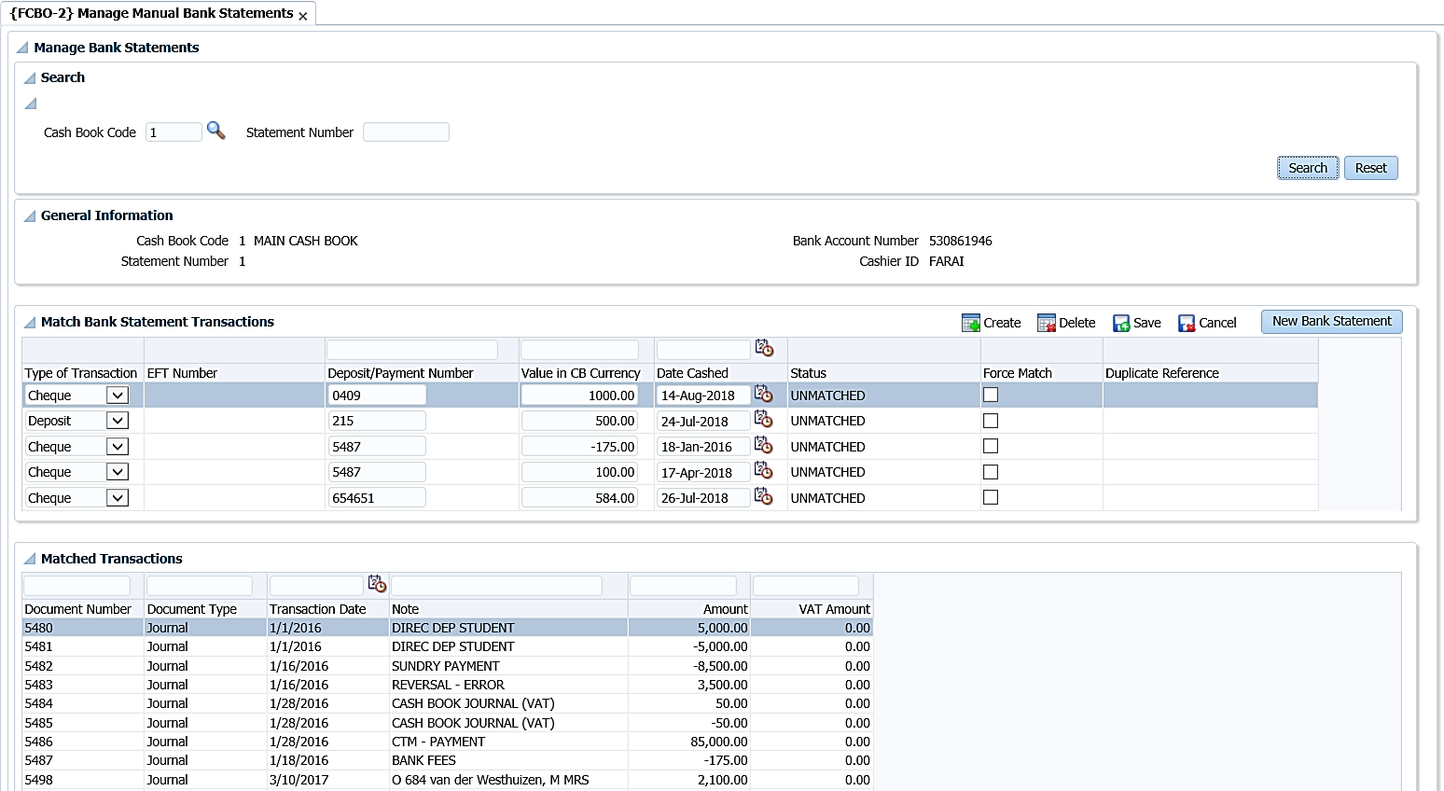

**Search panel box**

Once the user selects the cashbook code and the bank statement number in the 'Search' panel box, all the transactions that have been previously entered for the that cashbook/statement combination will be displayed. These transactions are broken down into 2 panel boxes which are the Match Bank Statement Transactions and Matched Transaction.

**General Information panel box**

The cashbook code, statement number, bank account number and cashier ID will display in form format but are not updatable.

**Match Bank Statement Transactions panel box**

Type of Transaction: The user will have to select the type of transaction that they are capturing. The options valid from the drop-down list are as follows:

* Cheque: Cheque payments that were made.
* Deposits: Deposits made to the bank from money collected at the cashiers.
* EFT: Payments that were generated electronically via tape.

**EFT Number**: This is the journal number of an EFT that exists on the system that the user wishes to link to an EFT on the bank statement. A drop-down list is available, to view all unmatched EFTs that exist in the system.

**Deposit/Payment Number**: The transaction number, as it appears on the bank statement.

**Value in CB Currency**: The transaction amount, as it appears on the bank statement.

**Date Cashed**: The transaction date, as it appears on the bank statement.

**Status**: Read only field that is used to inform the user of the status of the transaction that they have entered. The 5 statuses are as follows:

* Matched: The Deposit/Payment/EFT Number is found, and the amount is correct.
* Incorrect Value: The Deposit/Payment/EFT Number is found but the amount is incorrect.
* Unmatched: Cannot find a match for the Deposit/Payment/EFT Number and amount.
* Cancelled: Cheque was found, but was cancelled.
* Duplicate: More than one transaction found for Deposit/Payment/EFT Number and amount.

**Force Match**: It allows the user to clear the scratch pad table for a specific cashbook. When the user checks the 'Force Match' box and saves, a cashbook journal will be generated for the transaction.

* If the status is 'Unmatched ' or 'Cancelled', the system will use a transaction type linked to event 'C2' for deposits and 'C3' for cheques to process the cashbook journal.
* If the status is 'Incorrect Value', a journal will be created for the difference in the amount. If the amount must be decreased, then the transaction type linked to event 'C3' will be used otherwise the transaction type for event 'C2' will used.

**Duplicate Reference**: This field will display a drop-down list if a payment number is entered and the system finds that the number exists more than once on the system. This will only occur if the cheque that was processed was done outside the system and captured more than once in {FCTO-6} as a manual cheque entry. The user will have to select the correct entry from the drop-down list and save the record.

**Note:** The duplicate cheque will have to be reversed from the system.

**Matched Transactions panel box**

Displays transactions that have been matched to the statement.

## Bank Statement Reconciliation {FCBO-4}

This option serves to verify the correctness of the transactions entered from the bank statement. For this purpose, all the transactions in the journal, cheque and scratch pad table linked to the specific bank statement number will be considered to calculate the closing balance from the opening balance. If the calculated balance is the same with the bank statement balance, all the transactions were entered correctly but all the transactions are not necessarily matched. Once all the transactions in the scratch pad table are updated, force-matched and the calculated closing balance corresponds with the balance on the bank statement, the transactions are flagged to indicate that the reconciliation process was completed successfully.

**See Example below {FCBO-4}**

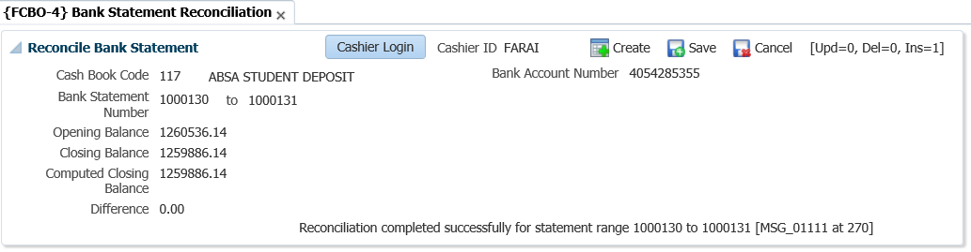

**Cashbook code**: The code of the cashbook that must be reconciled. The cashbook description will be display once entered or selected from the list of values.

**Bank Account Number**: Displays the bank account number of the cashbook.

**Bank statement number from**: The starting bank statement number that must be reconciled

**Bank statement number to**: The end bank statement number that must be reconciled. If a range is specified, the transactions of all the statements in between must have been entered

**Opening balance**: The opening balance as it appears on the first bank statement that must be reconciled.

**Closing balance**: The closing balance as it appears on the last bank statement that must be reconciled.

After the above details have been completed, the user should <SAVE> to reconcile.

**Computed Closing balance**: The system uses the opening balance (as provided) and the transactions linked to the bank code and range of statements (as provided) to calculate a closing balance. This calculated balance is displayed in this field.

**Difference**: The difference between the closing balance as provided and the calculated closing balance is displayed in this field.

## Manage Cheque Matching

The screen-print below shows cheques that are matched.

**See Example below {FCBO-11}**

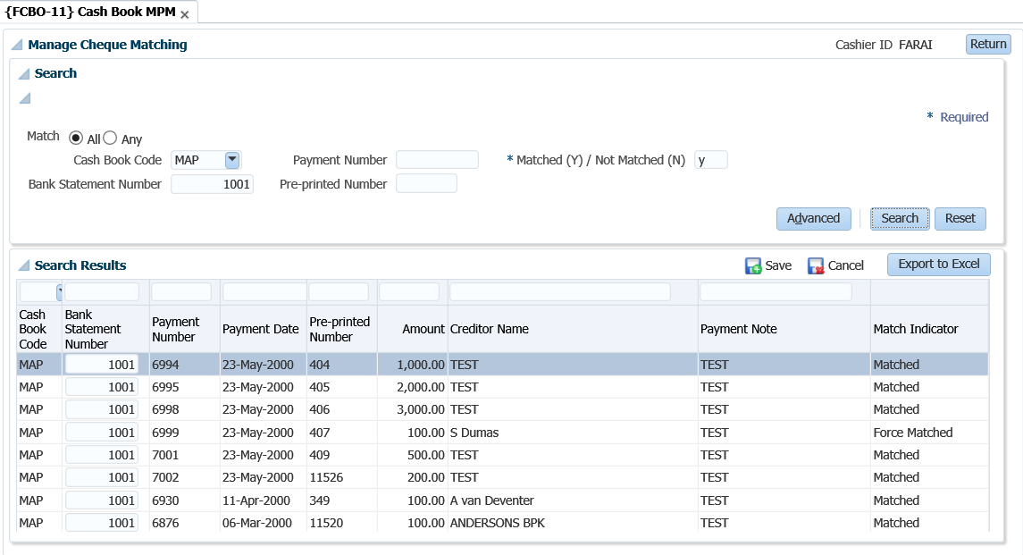

The following screen-print displays unmatched cheques.

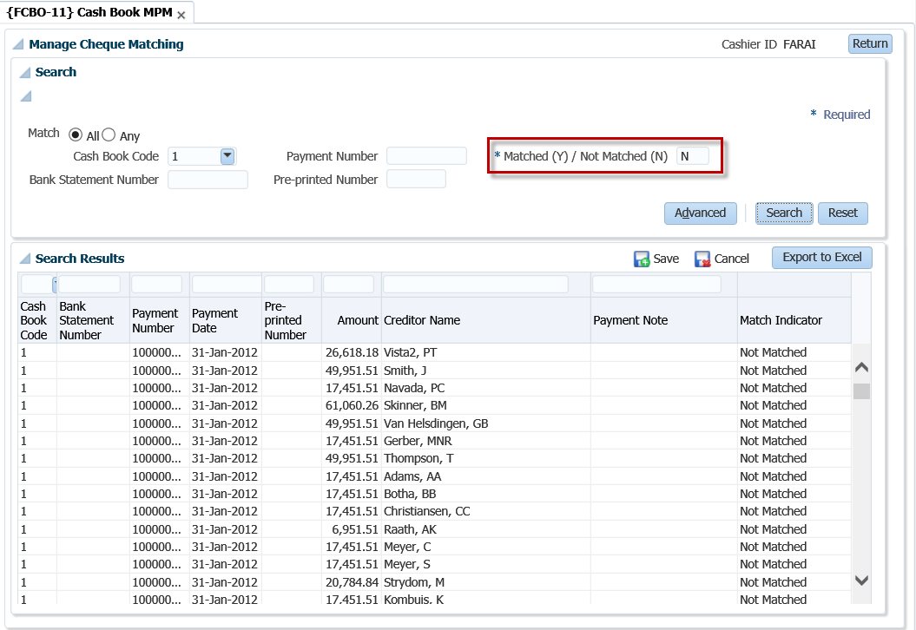

## Cashbook Transfers {FCBO-5}

This option serves the same purpose as option {FCBO-1}, except that two transactions are generated in the journal table, one for each cashbook. These transactions are driven by events “CO: transfers out” and “CI: transfers in”, and transaction types will have to be linked to these events. The two transactions can then be matched individually from the bank statements.

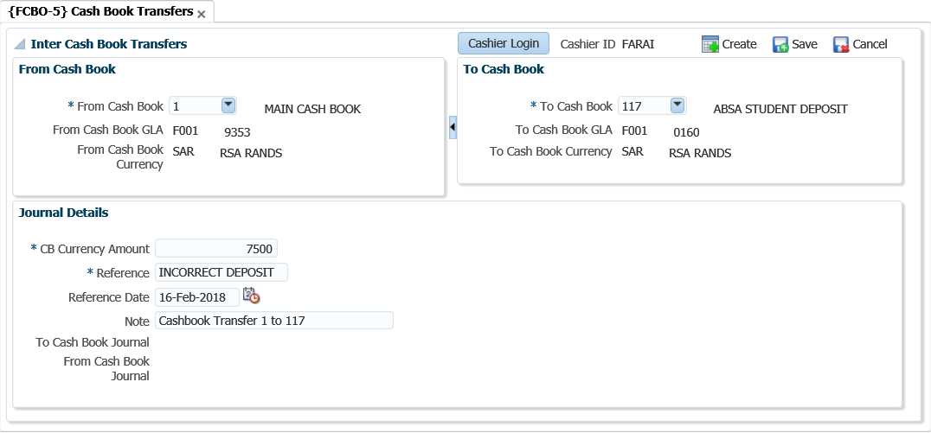

**Cashbook from**: enter the cashbook code from which money must be transferred.

**Cashbook to**: enter the cashbook code to which money must be transferred.

**Amount:** the amount that must be transferred.



**Note** **:**When you save, the system will generate the two transactions linked to events “CO-transfers out” and “CI-transfers in”.

## Maintain Electronic Bank Statement {FCBO-21}

This task on the MPM is a combination of {[FCBO-21](http://wlint4.adaptit.co.za:7700/itshelp/faces/helppages/config.OHW+Servlet+1/topics/navSetId.itshelp/itshelp/documents/fcbo-21.html)} & {[FCBO-22](http://wlint4.adaptit.co.za:7700/itshelp/faces/helppages/config.OHW+Servlet+1/topics/navSetId.itshelp/itshelp/documents/fcbo-22.html)} and is used to maintain and match transactions on an electronic bank statement. Options {FCBO-21}, {[FCBO-22](http://wlint4.adaptit.co.za:7700/itshelp/faces/helppages/config.OHW+Servlet+1/locale.en/topics/navSetId.itshelp/itshelp/documents/fcbo-22.html)}, {[FCBO-23](http://wlint4.adaptit.co.za:7700/itshelp/faces/helppages/config.OHW+Servlet+1/locale.en/topics/navSetId.itshelp/itshelp/documents/fcbo-23.html)} and {[FCBO-24](http://wlint4.adaptit.co.za:7700/itshelp/faces/helppages/config.OHW+Servlet+1/locale.en/topics/navSetId.itshelp/itshelp/documents/fcbo-24.html)} are used to process and  reconcile bank statement downloaded electronically. On converting an electronic bank statement, the system attempts to match all deposits and cheques. Any cheques or deposits that couldn’t be matched and other transactions on the statement are written into a table which can be maintained in this option.

In order to process transactions in the table, the cashier will enter the appropriate transaction type and or cost centre and account or linking the journal number before running the match electronic bank statement program {FCBO-22} which will generate cashbook journals. On reconciliation of a bank statement, the closing statement balance is inserted into the table and all records written to the table for the bank statement excluding the closing balance are deleted.

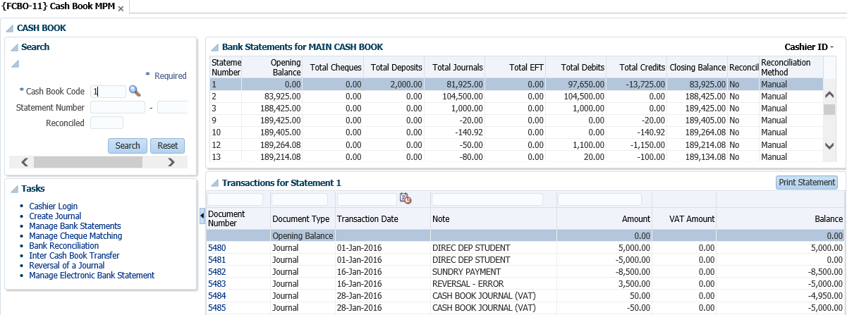

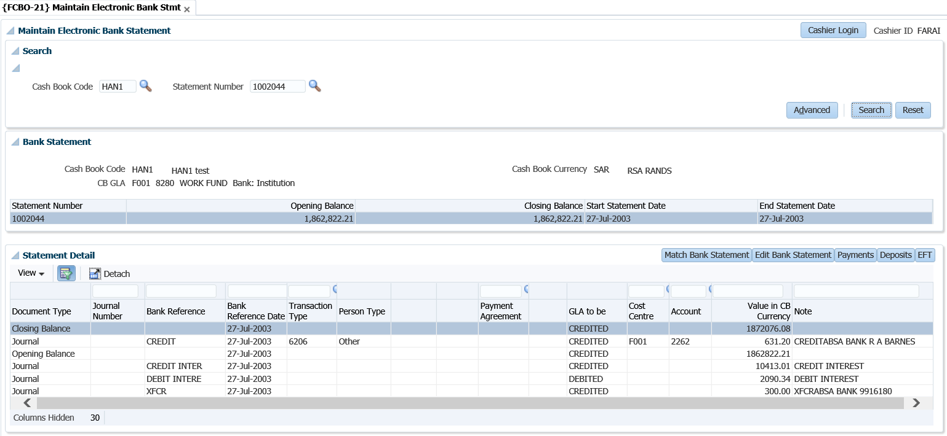

**Search panel box**

**Cashbook Code**: Allows the user to search for a cashbook code. The list of values will display the code, description, CB GLA and CB currency code.

**Bank Statement Number**: Allows the user to search on bank statement number or cashbook and bank statement number. The list of values will display the statement number, maximum reference date and statement closing balance.

**Bank Statement panel box**

The form layout displays cashbook code, cashbook currency and CB GLA returned for the search. The statement number, opening balance, closing balance and statement date range are displayed in a table.

**Statement Detail panel box**

Information cannot be updated in the table; the Edit Bank Statement button must be used to maintain the cashbook journals.

**Document Type**: Indicates if the record related to journal, deposit or payment. Only journals can be maintained in this option

**Journal Number**: The unique transaction number, which is allocated programmatically when a journal is created.

**Bank Reference**: The reference number of the transaction as it appears on the bank statement.

**Bank Reference Date**: The transaction date as it appears on the bank statement.

**Transaction Type**: Journal processing is driven by the transactions type. The transaction type indicates the person type and other subsystem is affected by using the transaction type. The transaction type also determines which of the fields that follow are required and / or updateable and whether the journal relates to input or output for VAT / GST purposes. The transaction types are defined in {FCSO-7}.

**Person Type**: Depending on the transaction type definition, one of the following values will be displayed:

* (S)tudent Debtor
* (P)ersonnel
* (C)reditor
* Normal (D)ebtor
* (A)lumnus
* (O)ther

**Person Number**: The person number field is mandatory if the person type of the transaction is (S)tudent, (D)ebtor, (C)reditor, (P)ersonnel and (A)lumni. For person type (O)ther, this field is not mandatory, but a number can be used if the person was created on the system and has a biographical record.

**Account Type**: The account type will default from the transaction type, but can be updated by the user if so defined on the transaction type definition. The account type field is mandatory if the person type of the transaction is (S)tudent, (D)ebtor or (C)reditor. For (P)ersonnel and (O)ther, this field is also mandatory if the card indicator on the transaction type definition is (Y)es. If this indicator on the transaction type definition is (N)o, an account type is not needed. If person type is (S)tudent, (C)reditor or (D)ebtor, a list of valid account types for that person type will be available. It will also show the balance for the account type / payment agreement combination for (S)tudents. The user will only be able to process a transaction on one of these valid account types or the default account type defined for the student debtor subsystem. The program will validate that the subsystem / account type combination is valid and active.

**Payment Agreement**: When a transaction is processed for person type (S)tudent, the user will have to enter a payment agreement for the transaction. A list of valid values for the specific student will be available from which to choose. This is a mandatory field for person type (S)tudent unless the transaction is processed against the default account type, in which case the field will be null.

**Loan Code**: The staff loan code or student loan code, if applicable, can be entered here. For staff debtors, the cumulative principal repayment and the reducing principal (outstanding amount) {FARPD-2 b2} will then be updated with the amount of the payment. It is essential that the account type used be linked to a category “S” (Staff Loans) otherwise the user will not be allowed to enter a loan code. For student loans, the real payment amount, as indicated on the amortisation schedule {FBLO-22} Tap 4, will be updated with the payment amount when the next amortisation calculation is run. Again, it is essential that the account type used be linked to a category “L” (Student Loans) otherwise the system will not allow the user to enter a loan code.

**GLA to be**: GLA to be Debited / Credited is displayed depending on the transaction type definition.

**Cost Centre**: The cost centre to be debited or credited. The cost centre and account are not updateable if the person type above is Student, Creditor or Debtor or where an account type is used.

**Account**: The account to be debited or credited. The cost centre and account are not updateable if the person type above is Student, Creditor or Debtor or where an account type is used.

**Given Currency Amount**: The value of the transaction, in each currency. Given currency value is the value of the transaction in the currency of the Debtor / Creditor after converting the Cashbook amount received to local currency and the local currency value to the debtor / creditor currency.

**Note:** A note for the subsystem transaction may be entered. If the debtor / creditor is a (S)tudent, the note will default from the transaction type note, but may be updated.

### Match Bank Statement

Selecting the button navigates to the "Maintain Electronic Bank Statement” option {FCBO-21} which allows the user with access to run the option to convert a bank statement.

**See Example below {FCBO-21}**

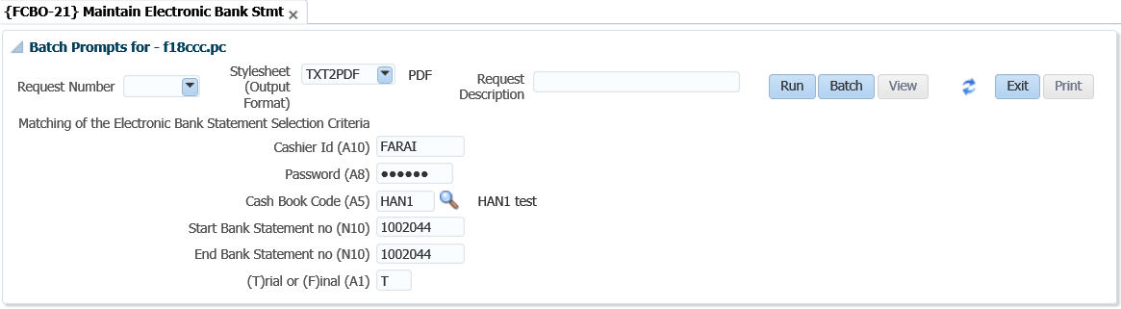

### Edit Bank Statement

Cash book journals cannot be maintained in the Statement Detail panel box. The cashier must use the Edit Bank Statement button to open the edit screen. Clicking the button opens the "Edit Electronic Bank Statements” screen which allows the user to maintain the journals displayed in the table.

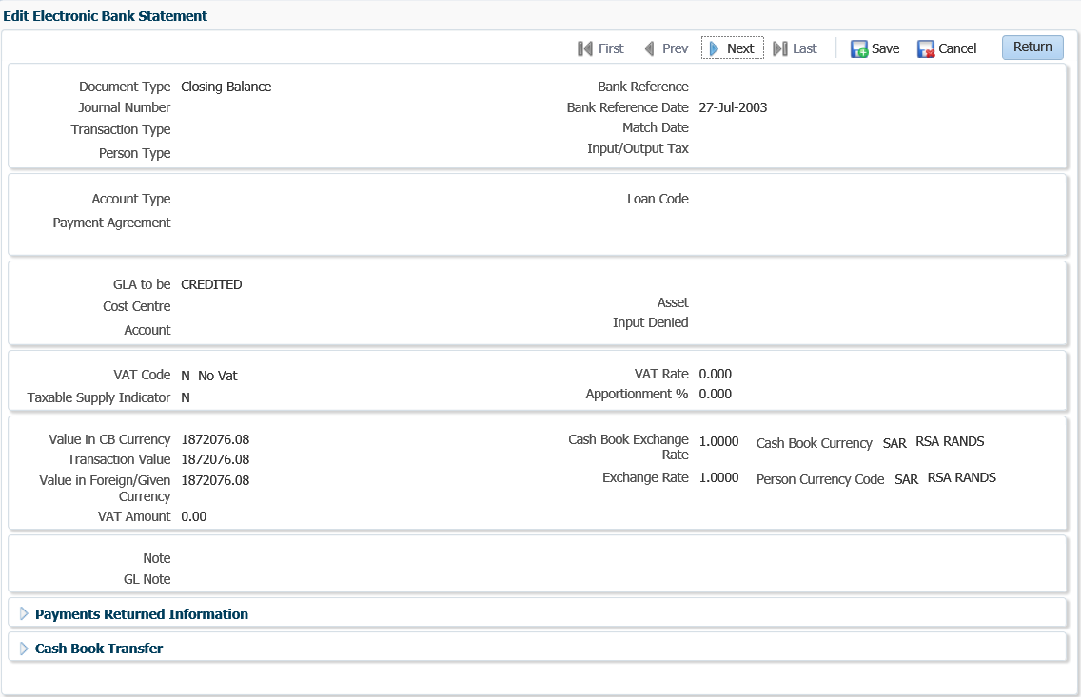

**Payments Returned Information**

**R/D Indicator:** If an R / D cheque is processed this indicator may be set to (Y)es.

**Cheque Number**: If a cheque was returned from the bank, the cheque number of the returned cheque can be entered here.

**Branch**: The branch code of the returned cheque can be entered here.

**Cheque Date**: The date of the returned cheque can be entered

**Cashbook Transfers**

**Transfer Cashbook**: The Cashbook code from / to which money is transferred.

### Payments

When you click on the *Payment* button, the following window pops-up:

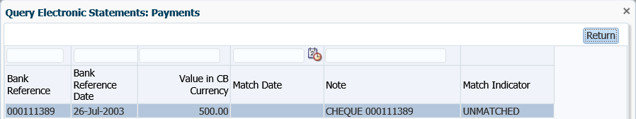

### Deposits

When you click on Deposits, the following window pop-up:

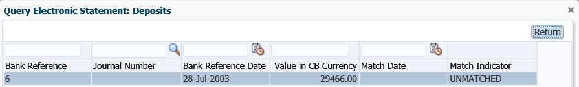

### EFT

When you click on EFT, the following pop-up window appears:

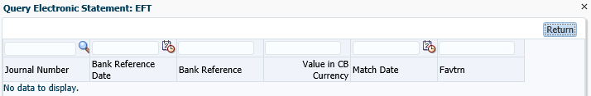

## Process Incoming Bank Files {FACMR1-2}

This Option is used to Process Incoming Bank Files





**None**: This program executes automatically in the background. The program checks all files loaded in the directory for incoming bank files and depending on the file name it knows which program (SSVS, AVS, EFTS, Bank Statement or Transact Alert) to call to process the file and email the output to the user specified.

Example:

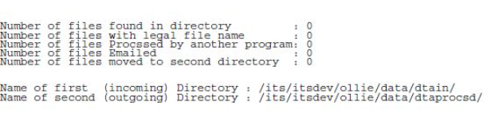

**Processing Rules:** Reports will be generated indicating the errors and the user will be notified automatically that records are verified as correct and will be updated accordingly.

Generating files for Standard Bank:

* ACCV file for Standard Bank - {FACM-6}
* SSVS file for Standard Bank - {FACM-5}
* EFTS file for Standard Bank - {FPRNB-1}
* Error Codes - {FACO-23}.

Processing files from Standard bank:

* Bank Statement files {FEBC-9}
* Transact Alert files

## Maintain Electronic Statement- Standalone {FCBO-28}

This menu option serves the same purpose as {FCBO-21}, except for the Match Bank Statement” functionality. The main difference is the interface, i.e. in {FCBO-21} the user must drill down using the buttons whilst {FCBO-28} has a form layout to maintain the journals.

**See Example below {FCBO-28}**

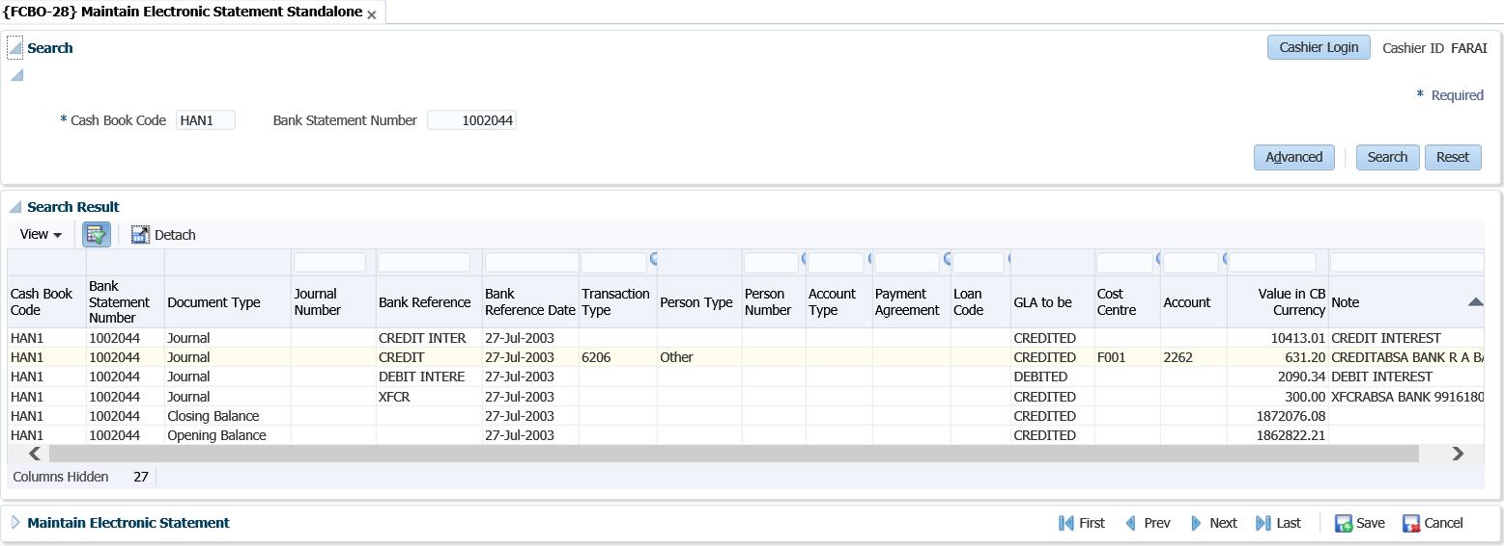  
**Form layout**

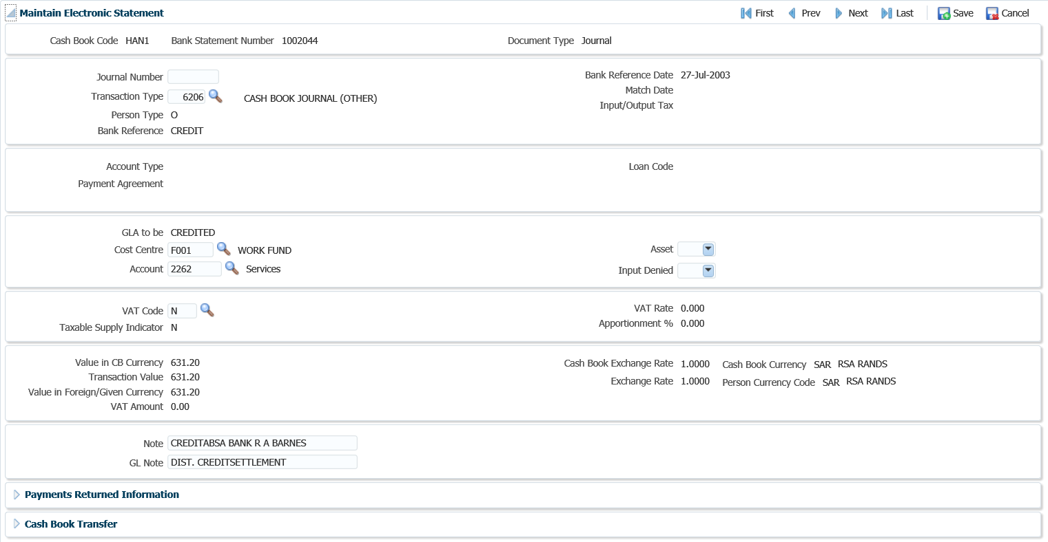

## Query Unreconciled Cheques {FCBO-6}

This option allows the user to update the bank statement on payments where the bank statement has not yet been reconciled.  The screen either lists payments that have not been linked to a bank statement or payments linked to bank statement not yet been reconciled. The user can change the bank statement number on an unreconciled bank statement.

**See Example below {FCBO-11}**

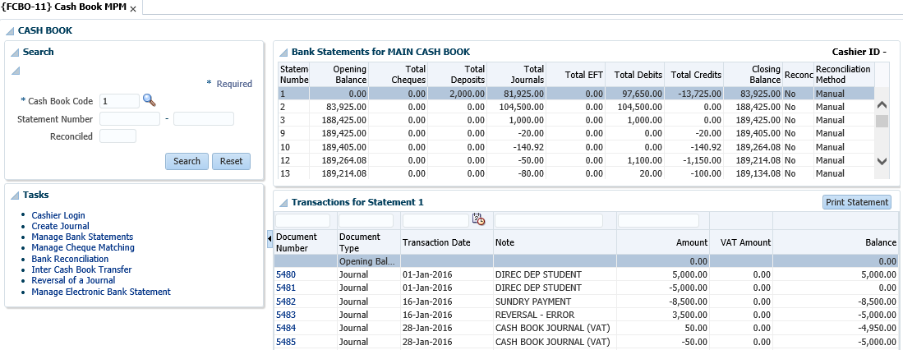

**See Example below {FCBO-6}**

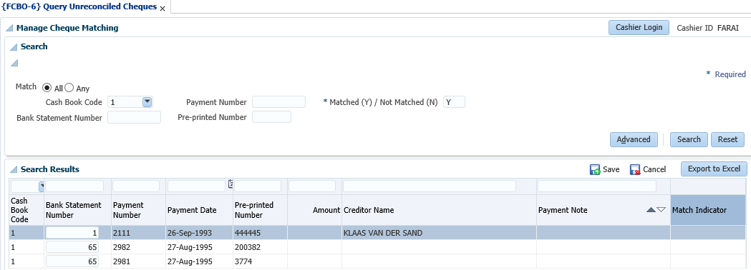

**Search panel box**

The user can search unreconciled payments per cashbook code, payment number, matched Yes / No, bank statement number, pre-printed number or any combination thereof or do an advance search. The Matched (Y) / Not Matched (N) indicator is mandatory.

**Search Results**

**Cashbook Code**: The bank account against which the cheque was issued.

**Bank Statement Number**: The bank statement number on which the cheque was matched.

**Payment Number**: The internal cheque number.

**Payment Date**: The date on the cheque.

**Pre-printed Number**: The external cheque number.

**Amount**: The amount on the cheque.

**Match Indicator**: Whether the cheque was (C)ancelled, (N)ormal or (F)orced matched.

**Name on the Payment**: The Creditors name.

**Note on Payment**: Displays the payment note

**MODULE**

**3**

# **Query Menus (not in MPM)**

Specific outcomes

On completion of this module, you will be able to:

* Query budget general ledger accounts.
* Query statement journals.

## Introduction

This section covers the query functionalities not incorporated in the cashbook MPM.

## Query Budget GLA {FCBO-9}

The user can query budget or actual GLA totals and detail, within the security rules. The form layout is used to capture the query criteria before clicking on the Submit button. Mandatory fields depend on nature of the query i.e. actual or budget. When you click on the “New Query” button, the following screen displays.

**Actual**

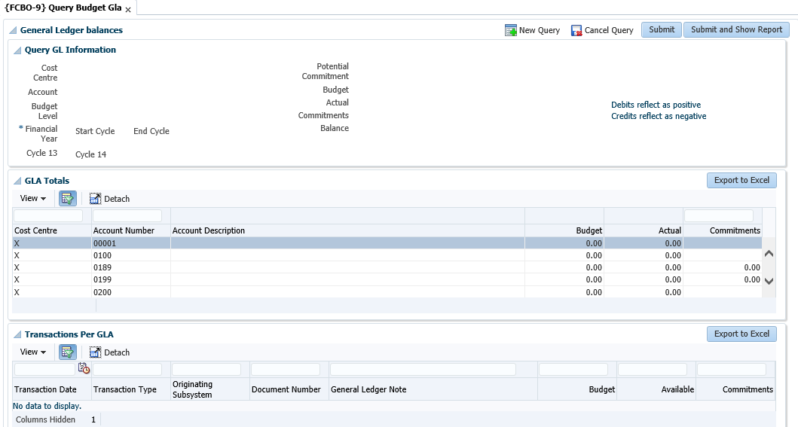

**Budget**

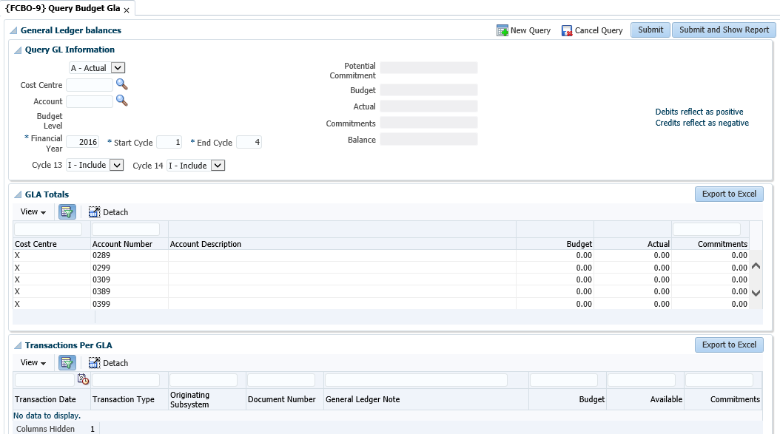

**Submit and Show Report button**

Click the button and a batch prompt that allows you to view or print the report will display.

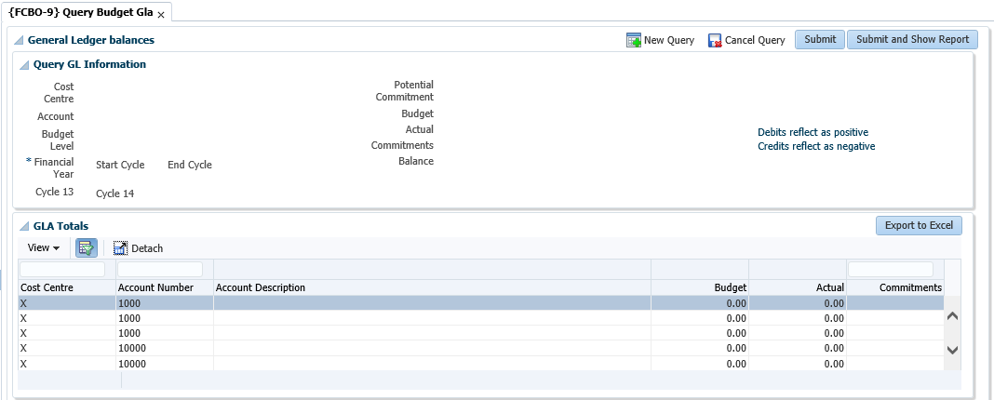

## Query Statement Journals {FCBO-10}

The purpose of this menu option is to enable the user to query transactions processed against a bank statement.

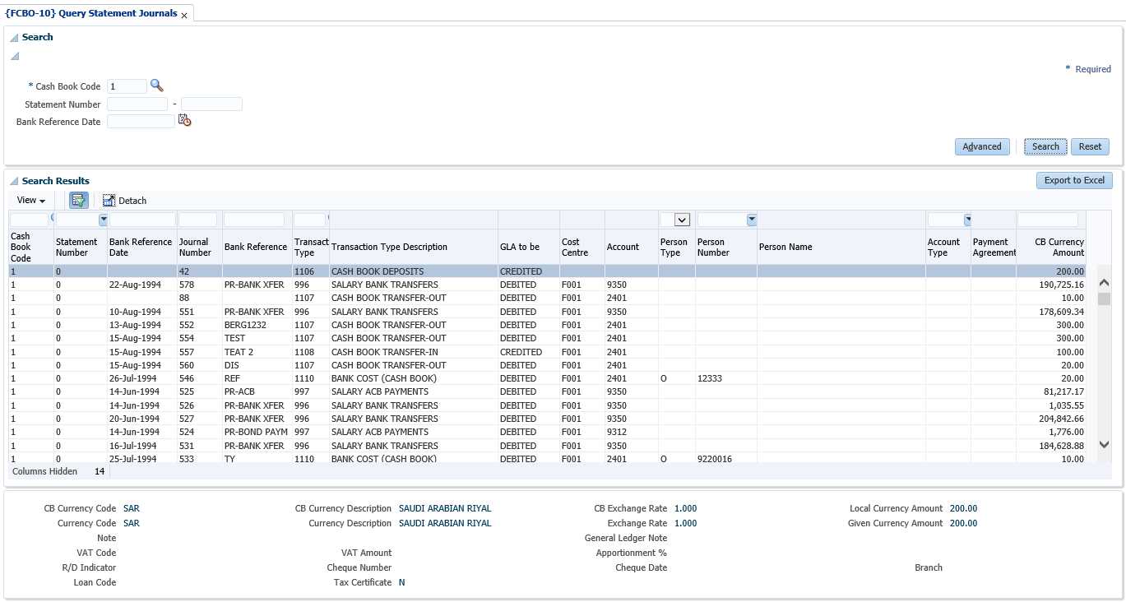

**Search**

Enter the cashbook code. The statement number range and bank reference date are optional. Leaving the statement number fields null will query all transactions for the cashbook.

**Search Results**

All fields in the table are display fields only and display the values as entered when the transaction was processed. Transactions are displayed in the same order that they were entered by the user or downloaded and processed from an electronic bank statement. The form at the bottom of the table shows the financial details of a transaction selected in the table.

**MODULE**

**4**

# **Reports**

Specific outcomes

On completion of this module, you will be able to generate the following reports:

* Bank statement.
* Bank reconciliation statement.
* Bank reconciliation at a specific date.
* Receipts payments not deposited.
* Deposit validation.

## Introduction

All the cashbook transactions are kept in these two sets of tables as indicated. When a bank statement is received, all the transactions must be entered from the bank statement into the system. Matching of the transactions is then performed online. The number of the bank statement is stored with the original transaction if a match is found. In the case where there is no matching transaction for the one on the bank statement, it is stored in a temporary table. Entries in the temporary table can then be force-matched with other groups of transactions. All unmatched transactions in the temporary table can be updated or deleted by the user. To ensure the successful reconciliation of a bank statement, there must be no transactions for that statement in the temporary table

**Reports to use for Cashbook reconciliation are:**

* {FCTOR1-1} Rec/Payments Trans per Type: Transaction per type report from counter system
* {FGLOR1-21} Transactions per Type: Transaction per type report from GL system
* {FCBOR1-1} Bank Statement Report: A report run from one specific bank statement to another
* {FCBOR1-2} Bank Reconciliation: A report which compares the subsystem to the GL. It also provides a list of transactions without bank statement numbers and statements that have not been reconciled
* {FCBOR1-5} Receipt Payments Not Deposited: A report that lists all the undeposited receipts
* {FCBOR1-7} Deposit Validation Report
* {FCBOR1-10} Bank Reconciliation as at a Specific Date

## Receipt / Payment Transactions per Type {FCTOR1-1}

This report reflects detail of transactions for a specified range of types and can be requested in summary or in detail. If all the transaction types for the CT Subsystem is requested the report will first list the receipt transactions and then the cheque transactions.

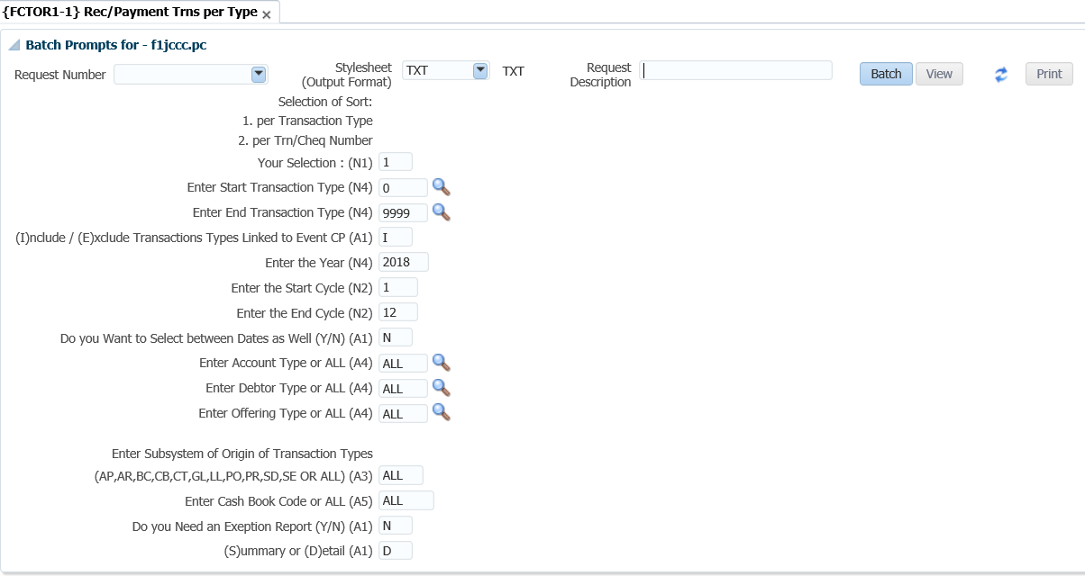

## Bank Statement {FCBOR1-1}

The user will be able to view a bank statement that was created in the cashbook, or view all unmatched transactions. This program will print according to the new transaction sequence. The user will thus be able to print bank statement transactions in the same order as they appear on the physical bank statement; if the transactions were processed in that order.

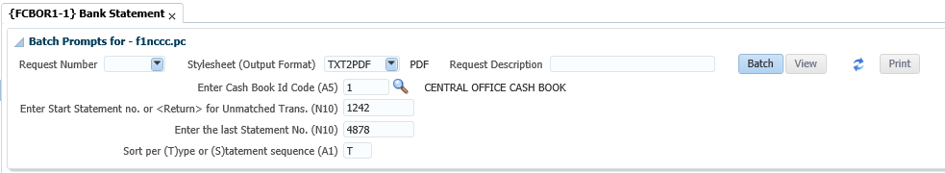

The parameters to be entered are:

* Cashbook ID code
* Enter Start Statement Number or <RETURN> for Unmatched Trans.
* Sort per (T)ype or (S)tatement sequence

Click on the view button and the following report will be generated:

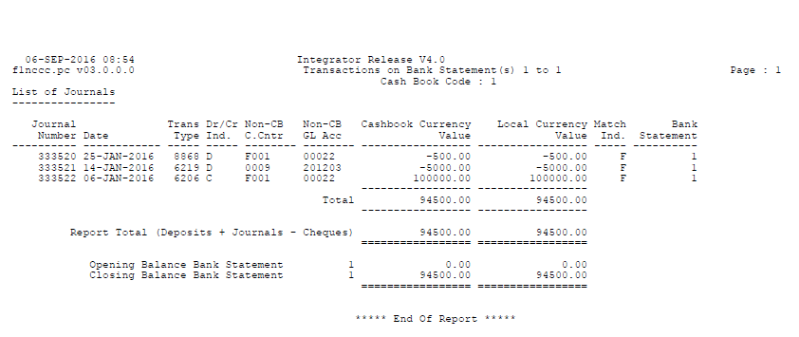

## Bank Reconciliation {FCBOR1-2}

This report is used to reconcile the balance on the bank statement with the balance of the cashbook in the General Ledger.  If the closing balance on the bank statement can be calculated from GL balance and all the outstanding items for that cashbook, no further detail is printed.  If, however it is not in balance, all the detail of unmatched transactions is printed.

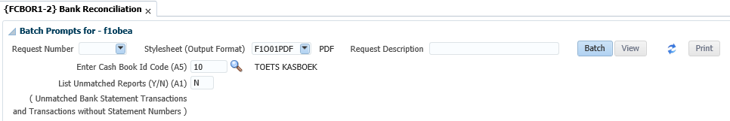

The parameters to be entered are:

* Cashbook ID code
* List Unmatched Reports (Y/N)

Click on the View button the following report will be generated:

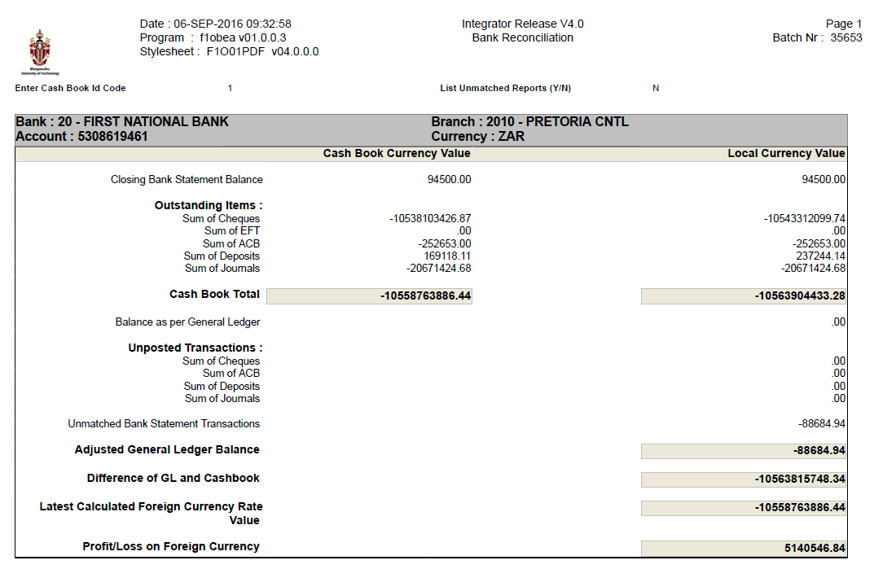

## Receipt Payments Not Deposited {FCBOR1-5}

When run, this report will retrieve a list of all receipts that have been processed in ITS, but have not been deposited to the bank (i.e. A deposit listing has not been run)

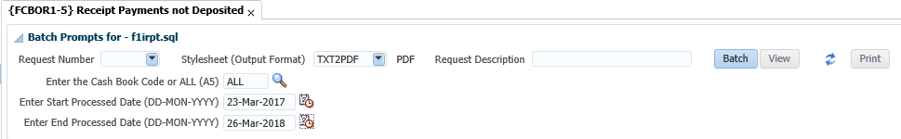

The parameters to be entered are:

* Cashbook Code
* Start Processed Date
* End Processed Date

Click on the View button the following report will be generated:

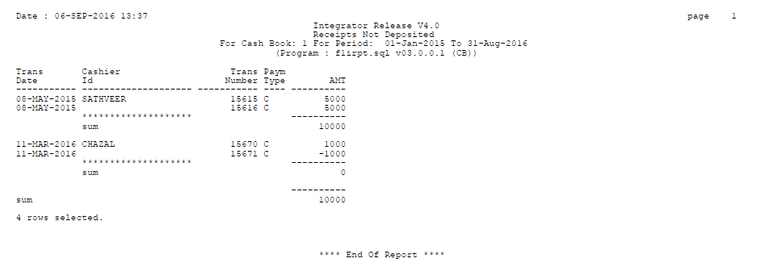

## Deposit Validation Report {FCBOR1-7}

This report lists all the cash-book deposit transactions according to the specified criteria but compares entries made on {FCTO-3} per deposit to deposits created in the cashbook.

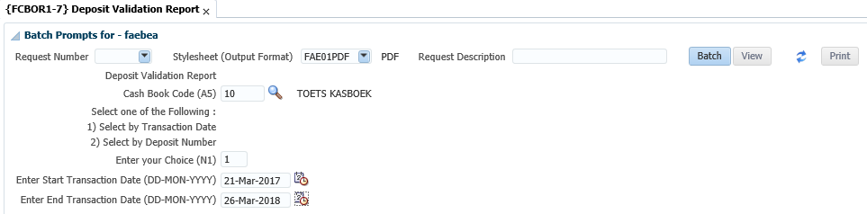

The parameters to be entered are:

* Cashbook Code
* Select 1 for Transaction Date (then enter start and end transaction date) or 2 for deposit number (then enter start and end deposit number)

Click on the View button the following report will be generated:

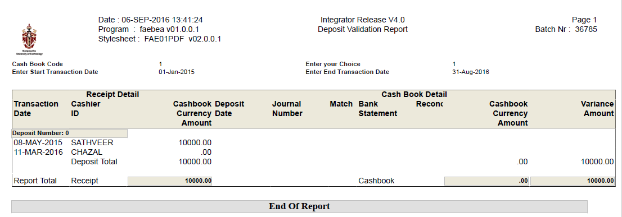

## Bank Reconciliation as at a Specific Date {FCBOR1-10}

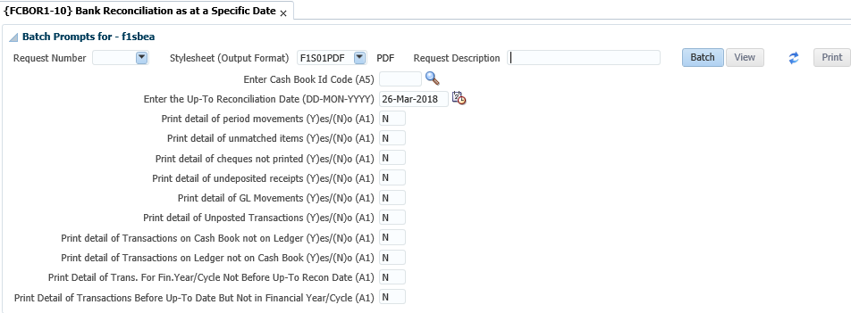

The following report will be generated:

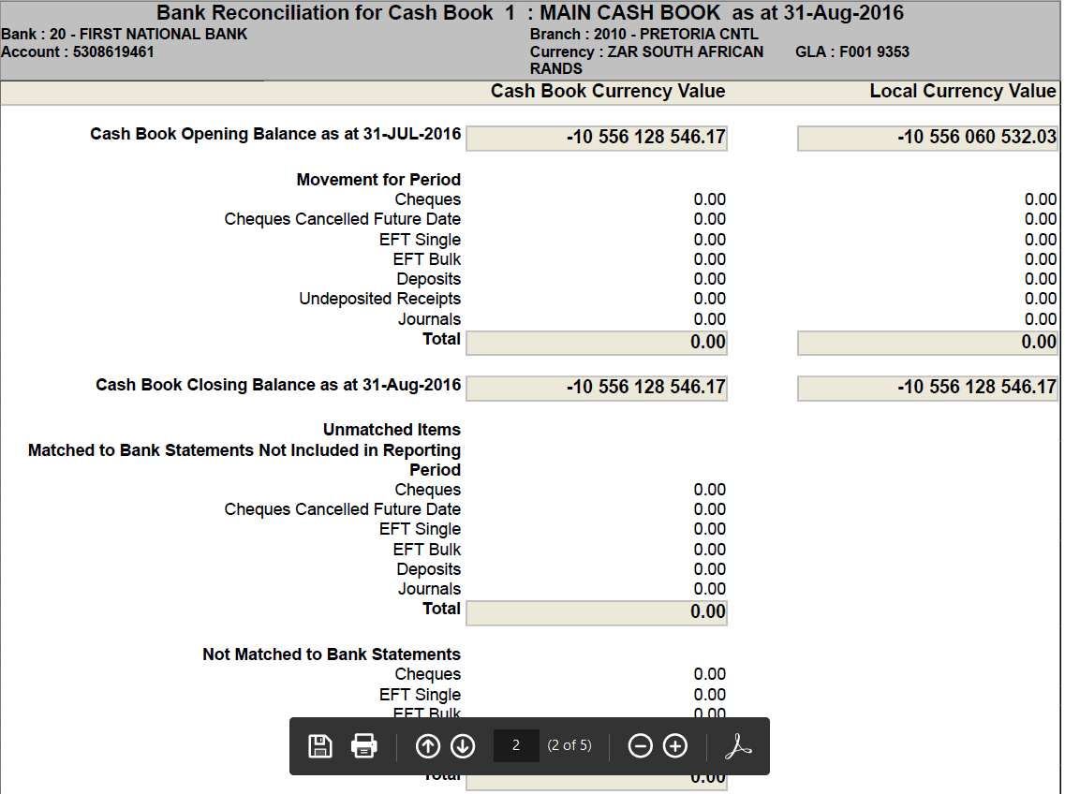

**Acronyms, Glossary & Terminology**

**Acronyms**

|  |  |
| --- | --- |
| **Acronym** | **Definition** |
| **DSL** | Data Sheet Layout (spreadsheet format of selected applications) |
| **DSR** | Document Storage and Retrieval |
| **EP** | Entry Point |
| **ES** | Entry Screen (menu/front end) |
| **iComms** | I-Communications - New Implementation of Selected Letters, Lists and Labels via Desktop Integration. I.e. Creating Letters with a Word Processing Application outside the ITS Back -Office System. |
| **iGrams** | A Visual Representation of Complex Data for Simplification. |
| **LOV** | List of Values |
| **OID** | Oracle Internet Directory |
| **PCL** | Printer Controlled Language |
| **PoE** | Portfolio of Evidence |
| **SMS** | Student Management System |
| **SSO** | Single Sign On |
| **URL** | Uniform Resource Locator. Usually pronounced by sounding out each letter but, in some quarters, pronounced "Earl" - is the unique address for a file that is accessible on the Internet. |
| **XML** | Extensible Mark-up Language. A mark-up language like HTML, used in reporting and iComms |
| **XSL** | Extensible Style sheet Language. A style sheet defining the output format of XML |

**Glossary**

|  |  |
| --- | --- |
| **Term** | **Definition** |
| **Block** | A section of screen that displays related information associated with a record. |
| **Canvas** | Any ‘white space’ on a screen. Right-clicking on the canvas usually offers additional options. |
| **Database** | An electronic system of storing and retrieving information so that it can be displayed according to a few predetermined formats. |
| **Execute query** | The act of conveying search criteria to retrieve and display selected data. |
| **Field** | A box on the screen that displays numeric or alphanumeric information, or permits numeric or alphanumeric information to be entered. |
| **List of Values** | A list of codes (numeric or alphanumeric) accessible through menus in certain fields.  **Note:** Is represented by an ellipsis or  at the end of the field. |
| **Output** | The displayed or printed result by which information is requested from the database through a query or entered search criteria. |
| **Query** | A database term for a search carried on one or more fields on a screen. |
| **Query criteria** | Search criteria used in a query. |
| **Record** | A data structure composed of one or more fields. |
| **Report** | The displayed or printed output resulting from report criteria used to generate a report. |
| **Report query** | Criteria used to search the database so that a report is generated. |

**Terminology**

|  |  |
| --- | --- |
| **Term** | **Definition** |
| **Academic structure** | This is the structure of all academic qualifications / study programs offered by a university, linked to a faculty, then to an academic department, and then linking all the subjects / courses / modules that form part of the curriculum to the qualification / program. It includes all pre- and co-requisites per subject / course, credits per subject / course / module, formats of offering and all relevant information related to the completion of a qualification, i.e. degree, diploma, etc. This structure is maintained on the university’s student information system. |
| **Analyze** | Interpretation  Apply of processes  Examine, Investigate, Consider, Evaluate or Scrutinizes |
| **Block** | A section of screen that displays related information associated with a record. |
| **Calculate** | Compute |
| **Canvas** | Any ‘white space’ on a screen. Right-clicking on the canvas usually offers additional options. |
| **Compile** | Collect, Assemble, Accumulate or Gather |
| **Copy** | Duplicate |
| **Database** | An electronic system of storing and retrieving information so that it can be displayed according to a few predetermined formats. |
| **Dean** | The person who has been appointed by the university as the academic head of a faculty. |
| **Department** | A sub-section of a faculty’s organizational structure, based on an academic field and / or main subject, whereas the department is responsible for the qualifications or study programs that are linked to the field or main subject. An academic department is headed up by a Head of Department (HOD). |
| **Execute query** | The act of conveying search criteria to retrieve and display selected data. |
| **Faculty** | A sub-section of a university’s academic structure, based on a collective but related number of study fields or subjects, e.g. Faculty of Medicine. A faculty is headed up by a Dean. |
| **Faculty Administrator** | The person who has been appointed to execute the administrative functions of a faculty that includes inter alia student administration, financial administration and committee administration. |
| **Faculty Manager** | The person who has been appointed to manage the overall administrative functions of a faculty, and who is a member of the faculty’s executive management team. |
| **Field** | A box on the screen that displays numeric or alphanumeric information, or permits numeric or alphanumeric information to be entered. |
| **Generate** | Create or Delete Data  Compute Results  Adjust Results  Print or Run a Report  Print or Run a List  Print or Run a Letter  Print or Run a Label  Print or Run a Log File |
| **HOD** | The person who is appointed as the head of an academic department. |
| **List of Values** | A list of codes (numeric or alphanumeric) accessible through menus in certain fields.  **Note:** Is represented by an ellipsis or  at the end of the field. |
| **Maintain** | Create, Capture, Insert or Enter Records  Delete, Purge Records  Update, Change or Rectify Records |
| **Output** | The displayed or printed result by which information is requested from the database through a query or entered search criteria. |
| **Query** | A database term for a search carried on one or more fields on a screen. |
| **Query criteria** | Search criteria used in a query. |
| **Record** | A data structure composed of one or more fields. |
| **Report** | The displayed or printed output resulting from report criteria used to generate a report. |
| **Report query** | Criteria used to search the database so that a report is generated. |
| **Rollback** | Reversal |
| **Screen** | All that relates to data can be displayed or entered in fields in one or more blocks. |
| **Utilize** | Query, View, Understand or Use Information |
| **Verify** | Check, Control, Confirm or Validate Information |

# **Help us enhance the course**

On completion of the Cashbook training, we would appreciate it if you take a few moments to give us your feedback on any aspect of this course. Your feedback might include comments on:

* Course content and structure.
* Course reading materials and resources.
* Course duration.
* Course support (assigned tutors, technical help, etc.)

Your constructive feedback will help us to improve and enhance this course.

# **Need help?**

You can refer to our online help manual available on the system or alternatively contact Adapt IT – Education: Consulting and Training

**Physical Address**

152 14th Rd

Noordwyk

Midrand, 1687

Johannesburg

South Africa

**Tel**: +27 (10) 494 0000

**Email**: [EDU.consulting@adaptit.co.za](mailto:EDU.consulting@adaptit.co.za)

**Website**: [www.adaptit.co.za](http://www.adaptit.co.za)